SCREENS AND FACES: USING SOCIAL COHESION AND ONLINE COMMUNICATION

AS PROXIES FOR LONELINESS EFFECTS ON HAPPINESS

A Thesis

submitted to the Faculty of the

Graduate School of Arts and Sciences

of Georgetown University

in partial fulfillment of the requirements for the

degree of

Master in Public Policy

by

Michele Giunti, B.S.

Washington, D.C.

April 11, 2023

Copyright 2023 by Michele Giunti

All Rights Reserved

SCREENS AND FACES: USING SOCIAL COHESION AND ONLINE COMMUNICATION

AS PROXIES FOR LONELINESS EFFECTS ON HAPPINESS

Michele Giunti, B.S.

Thesis Advisor: Paul Treacy, Ph.D.

ABSTRACT

The progressive increase in connectivity, while allowing for higher resilience to loneliness, has not decreased the effect that loneliness has on overall wellness. In addition, the lower quality of online based interactions and relationships may exacerbate unhappiness despite an increase in social activity. The paper explores the mediated relationship between loneliness and happiness, assuming that social cohesion and engagement will act as a buffer for loneliness’s negative effects. To do so, data is pulled from the General Social Survey and the American National Elections Study to analyze changes in online interaction rates between 2018 and 2020, and verifying if these were met with corresponding changes in loneliness and happiness self-evaluations. The Fixed Effects Multinomial Logit model revealed that social cohesion and political participation are effective predictors of wellness among unhappy people in situations of high loneliness. Furthermore, online communication is still significantly correlated with improvements in wellness among already happy people, though these results may be compromised by the confounding quality of online based relationships. A dual system utilizing frequent digital interactions for loneliness prevention and community engagement for wellness treatment is proposed, and European programs dedicated to fighting loneliness are listed as a base for policy construction and implementation.

*Keywords:* Online Communication, Loneliness, Health, Happiness, Social Cohesion

ACKNOWLEDGEMENTS

To my family, today so far, yet always close.

Semper Iuncti,

Michele Giunti

**TABLE OF CONTENTS**

Introduction 1

Literature Review 5

The Growing Importance of Online Communication 5

How Online Communication Relates to Loneliness 7

The Difficulty of Analyzing Direct Loneliness Effects 9

Social Engagement as a Mediator between Mental Wellness and Loneliness 12

The Detrimental Effect of Loneliness on Health 16

The Influence of Individual Characteristics and Context on Loneliness Effects 19

Data and Methods 21

Data Used 21

Addressing Missingness 23

Dependent Variable 23

Independent Variables 24

Controls 28

Model Specification and Testing 29

Empirical Results 32

Discussion 40

Online Connectivity as Loneliness Prevention 41

Reconnecting Lonely People to their Communities 42

Policy Implications 43

Limitations 44

Conclusion and Future Directions 46

Appendix A: Verifying Alternative Dependent Variable Correlation 48

Appendix B: Verifying Base Level Effects 49

References 50

**LIST OF FIGURES**

Figure 1. Loneliness Scales Ordered by Subjectivity and Targeted Characteristic 10

Figure 2. Modern Network Types 13

**LIST OF TABLES**

Table 1. Descriptive Statistics of the Selected Sample (Demographic) 22

Table 2. Political Participation Activities for Offline or Online Contexts 27

Table 3. Descriptive Statistics of the Selected Sample (Main Model Variables) 29

Table 4. Multinomial Logistic Fixed Effects Models (GSS Happiness) 35

Table 5. Relative Risk Ratios (GSS Happiness) 36

Table 6. Multinomial Logistic Fixed Effects Models (ANES Dependent Variable) 39

Table 7. Relative Risk Ratios (ANES Happiness) 40

**LIST OF APPENDIX TABLES**

Table A1. Covariance and Correlation Table for Happiness, Loneliness, and Health 39

Table A2. Multinomial Logistic Fixed Effects Models: Base Relationships (GSS) 40

Table A3. Multinomial Logistic Fixed Effects Models: Base Relationships (ANES) 40

# **Introduction**

The internet has made physical distance a surmountable limitation of peer-to-peer communication, as many today are able to stay continuously connected through their phones, tablets, computers and laptops (Scott et al., 2021). Through online communication, individuals in developed nations are able to remain connected with people all over the world at all times, increasing their social networks, empowering healthy behaviors through sharing, and increasing resilience to discord and mental distress (Lin et al., 2020; Kamalpour et al., 2020). However, while the quantity of communication might have increased exponentially, the quality of online interactions has struggled to pick up the pace, and the possibility remains of feeling isolated even within this solid global interactivity network.

The pandemic was a wakeup call for most supporters of digital networks, given that social isolation measures were met with distress, worry, and fear (McClain et al., 2021). In fact, increased bouts of social isolation and, particularly, of feelings of loneliness have been proven to bring sleep disturbances, poor estimation of health, depression and high suicide risk (Hwang, 2020; Hämmig, 2019; Rauschenberg et al. 2021). Even just the perception of having to endure protracted physical or emotional loneliness can bring about several stress related illnesses, such as cardiovascular irregularities, strokes and hypertension, citing also dysfunctional health habits and the worsening of existing chronic illnesses (Kim, 2021; Mohnen et al., 2011).

Unfortunately, the restrictions on physical meetings and interactions did in fact exacerbate loneliness among young US adults. Both students and elders were among the most impacted by isolation measures, with an overall decrease in the amount of basic social needs being met and an increase in mental illness comorbidity rates (Towner et al., 2022). Of the several studies conducted on the matter, Harvard’s 2020 report on loneliness remains the most influential: from a representative sample of 950 U.S. adults, about 36% of these had felt lonely by late October 2020, and 61% of them had developed depression in the same period (Weissbourd et al., 2021). On the other end, pooling from a series of national surveys conducted shortly before and during the pandemic, it is estimated that about 22% to 24%[1] of the US elderly population (65 and up) felt lonely regardless of pandemic-related quarantines (Cudjoe et al., 2020; DiJulio et al., 2018), leading to substantial rises in perceived isolation by 2020 and 2021. This can lead to cases such as those evidenced by the San Francisco social isolation study, which indicated that about half of a sampled pool of elderly from the city’s population was left abandoned without any form of social support, suggesting that citywide numbers may not be that much different (Kotwal et al., 2021).

Private Information and Communications Technologies services like Zoom, WhatsApp, Facebook and Facetime allowed for some form of coping through this forced isolation, by reestablishing communicative relationships with friends, family, and colleagues, as well as by maintaining an information network connecting vulnerable individuals to the outside world (Lee et al., 2021, Mander et al., 2020). The formation of these online communities acted as a temporary buffer to the negative effects of loneliness, much in the way that physical communities act as resilience mechanism in situations of extreme duress (Bergstrand & Mayer, 2020; et al., 2021).

In fact, reports by the GlobalWebIndex and the Pew Research Center suggest that the growth of internet use was accompanied by a gradual shift in the way that we experience the digital world, with people now growing more and more accustomed to online interactions and digital relationships (McClain et al., 2021).[2] Overall, the increased role of online communication in the country’s system of social support might have been accompanied by a resurgence of hope and a decrease in overall loneliness, as the increase in social isolation and mental health mediators such as self-esteem, self-efficacy, and social support has been proven to be significantly associated with increased online communication (Fawcett & Karastoyanova, 2022; Kearns & Whitley, 2019). However, there is little to be said about the effectiveness of digital communities in creating safe and effective spaces of interpersonal interaction.

To this point, communities driven by online communication operate differently from physical communities, substituting codependence due to proximity with less tightly connected interest-based groups (Groenewegen & Moser, 2014). Furthermore, online interactions tend to be employed as an auxiliary rather than as an alternative to offline interactions (Scott et al., 2021; McCully et al., 2011), and can often act as a crutch for individuals who prefer maintaining in person meetings to a minimum (Sessions, 2010; Turner et al., 2001). The problem with giving people a choice in the matter of meeting in person or online is that a void then begins to form between members of both online and physical communities, especially if both base their cohesion on strict online communication (Wellman et al., 2002). Ultimately, while digital interaction allows for remote and on-the-fly communication, the quality of the resulting relationship is stunted by the lack of physical social cues, sacrificing cohesion, trust, and group identification (Lee & Lee, 2010; Cullen & Sommer, 2010). Further, while mental health might be improved through the reduction of loneliness, an excess of online activity might actually cancel out the mediating effect of online communication on loneliness resilience factors and reduce the efficacy of existing communities at improving individual wellness (Vacchiano & Bolano, 2021; Gil de Zúñiga & Valenzuela, 2011).

There is little discussion surrounding this multidimensional aspect of online communication on loneliness, mental health, and social cohesion, especially compared to studies concerning physical communities and their overall effect on participating members. As such, the present research paper serves as an exploration of online communication within the context of nationwide events such as the pandemic, analyzing its perceived effectiveness at staving the negative effects of loneliness on individual wellness. In particular, the focus is on detecting mediating aspects of online-based social cohesion compared to offline-based social cohesion on mental health, while accounting for personal characteristics and preferences of connectivity. The period between 2018 and 2020 was chosen due to the higher probability of both engaging in higher online communication activities and being socially engaged. Verily, the period coincided with heavy restrictions in physical communication, and widespread political campaigns for the 2020 presidential election, increasing both individual digital footprints and overall political community involvement.

The study finds that loneliness, physical or emotional, influences wellness through indirect channels of peer-to-peer communication (Pittman, 2018), and that physical social cohesion has a more involved role in determining the strength of this relationship compared to online communication frequency. Policy implications of these findings are discussed below.

# **Literature Review**

## **The Growing Importance of Online Communication**

93% of Americans today claim to have used the internet at least once, vastly surpassing the numbers reported in 2000 (52%) and flagging this generation as one rich in freedom of communication and network expansiveness (Pew Research Center, 2021). The increase in connectedness entails a higher level of social support distribution across all members of society, though preexisting inequalities can persist through secondary aspects of socioeconomic and racial inequalities, such as internet broadband access, technological education, and choice of primary tech use (Le-Phuong et al., 2022). Regardless, gaps in age, race, and gender have been closing up when considering modern internet use[3], and the pandemic has accelerated this trend due to the physical restrictions of social isolation and the consequent rise in connectivity needs. Particularly among young adults, internet participation has become more essential than ever (increasing from 62% of daily task consumption in 2020 to 72% in 2021; McClain et al., 2021), due to its function as an information sharing platform and distant communication method, as well as a research and emotional sharing tool (Wong et al., 2021).

To this point, online communication has become more and more associated with offline communication within relationship building and social network expansion, even if the two methods produce and manage social interactions in entirely different ways. In fact, platforms like social media allow us to remain connected at all times with our family, friends, colleagues and acquaintances, while also increasing the size of our social sphere, but the perceived social engagement of online interactions does not necessarily reduce one’s feelings of social isolation (Steafnone et al., 2011). Without taking into account the negative aspects of online communication[4], online interaction remains inferior to face-to-face interaction in its ability to provide strong and intimate relationships without the need for external support (Ahn & Shin, 2013). In fact, online communications systems that are supported by real life interactions provide great wellness benefits to all social groups, but the independent effect of online communication itself is hidden by its attachment to real life relationships (Kim et al., 2019; Bekalu, 2021; Scott et al., 2021).

For this reason, the role that online communication alone plays in affecting face-to-face interactions is ambiguous. Some researchers believe it directly enhances relationships (Lee & Lee, 2010; Yu et al., 2016) and increases the positive effect of potential areas of connection within neighborhoods and existing relationships across residents (Fong et al., 2021; Bergefurt et al., 2019). Additionally, the lack of physical limitations allows for a diversification in one’s own close tie network, mixing people whose distance would have normally precluded any form of interaction (Hampton et al., 2021), and allowing for an easier introduction to community norms (van Eldik et al., 2019). Others, like Kearns and Whitley (2019), as well as Fawcett and Karastoyanova (2022), note that, though internet-based communication does allow for a consolidation of social norms and a reconnection of vulnerable groups (i.e. seniors, minorities etc.), it does so through unstudied effects that differ from the known relationships between offline communication and wellness factors.

*Research Question 1*: Does loneliness cause decreases in wellness even if people engage in digital communication?

## **How Online Communication Relates to Loneliness**

As stated before, while acting as a support tool for offline communication, online interaction and its consequently formed relationships only superficially reproduce the cognitive and physical benefits of social interactions. Analyses by Biester (2020; 2021) on online discussion groups suggested that these do not form consolidated identities as physical communities do, and tend to grab norms and terminology from the latter without necessarily transforming them into a detached and unique community culture. For instance, when the pandemic hit its highest infection point, online support groups tended to address concerns related to external distress[5], rather than internal distress, even if providing space to express depression, illness, and pre-pandemic conditions was the original intent of the group (Low et al., 2020). In essence, the independence of online networks seems fragile when faced with the presence of offline networks, and the former come quickly to rely on the latter to strengthen the relationship ties of which they are formed.

The reason cycles back to the prevalence of weak, bridging, ties of relationship which are easier to form, maintain, and reconstruct within online communication. These exist along strong, bonding, ties deriving either from the offline transposition of pre-existing relationships or from an acclimatization to preferring online activities (Filiposka et al., 2017), a combination which negatively impacts an individual’s happiness and increases marginalization due to age, race, relationship status, or income (Forthman et al., 2021). While weak ties can benefit individuals by increasing their feeling of connectedness, the lack of a real output of social capital (i.e., trustworthy social nets, emotional support, physical aid etc.; Lee & Lee, 2010; Vacchiano & Bolano, 2021) creates a sense of disengagement that is not rationalized as a consequence of online presence. In some cases, the discomfort is misattributed to a deficiency of online social engagement, especially among lonelier, unhealthy, or unwell individuals, which continue to increase their online presence, without directly attributing the disengagement they feel to it. (Kim, 2017; Pittman, 2018).

Contradictions are then formed among those who benefit from prioritizing either their online counterpart (Chopik, 2016) or their offline identity (Shakya & Christakis, 2017), and those that misinterpret their need for offline connectedness, often due to high loneliness, as a drive for online network expansion (Kim, 2017; Wirtz et al., 2021; Pittman, 2018). The result is an overwhelming number of individuals who feel lonely even if they actively engage with their social relationship network, overvaluing their short-term improvement in wellbeing over the long-term issues[6] of exclusively communicating online (Atkinson et al., 2020). As mentioned, the misattributed benefits of online interaction can lead people to prefer it over offline interactions (Zhang & Sung, 2021), increasing the number of communities united by interests, rather than reciprocity (Gil de Zúñiga & Valenzuela, 2011)[7].

The problem presented has then three layers of complexity, which are summarized by Figure 1 below:

1. Online Communication creates high levels of loneliness due to the superficial nature of its relationships.
2. While doing do, it also provides short-term satisfaction which tricks people into thinking that they are benefiting from its use, thus employing it more.
3. As a consequence, their loneliness increases, causing individuals to increasingly need more online activity, up to the point where they might even prefer it to offline communication.

The resulting issue is an inability to carefully measure loneliness and its effects through direct means of self-evaluation, and even just accounting for online communication might not be enough to understand how truly lonely a person feels.

**H1**: High levels of online communication will have a significant negative effect on wellness.

**H2**: Individuals with both high levels of online communication and high levels of loneliness will experience significant positive effects on wellness.

## **The Difficulty of Analyzing Direct Loneliness Effects**

Due to the subjectivity of respondent loneliness, and the variety of definitions assigned by questionnaire-based research, social analysts find it difficult to quantify loneliness on a national scale. This is because loneliness is based both on how an individual perceives the effectiveness of its relationship circle, and how the current needs of society prioritize specific tools of interaction. As such, operationalizing loneliness requires the simultaneous consideration of internal and external expectations of social connections, which can become complex when synthesized onto a simple survey questionnaire.

Omitting any of the two causes researchers to focus on either physical or emotional loneliness, the latter being a lack of meaningful connections, or an accumulation of what Putnam defines as bridging social capital as opposed to bonding social capital (common in online networks), while the former is a more concrete loss of connections paired with a restriction in establishing new ones[8] (similar to pandemic social isolation measures; Holt-Lunstad & Steptoe, 2022). Since there are overlapping features between both, measurement of one tends to undermine measurement of the other, because direct questioning may cause respondents to prioritize thinking about one, due of primacy, or misinterpret the intention of the question due to their being unaware of the existence of two different types of loneliness.

Accordingly, the functions of physical/emotional loneliness scales vary depending on their concentration on measuring feelings or the extension of one’s social network (Cramer & Barry, 1999). Of these, the UCLA Loneliness Scale (Russel, 1996) is the most widely used, along with the Social and Emotional Loneliness Scale for Adults (SELSA; DiTommaso & Spinner, 1993) and the de Jong-Gierveld Loneliness Scale (Jong-Gierveld, 1987) standing in at a close second. Most of these scales do indeed try to measure loneliness (Figure 1; Valtorta et al., 2016) while balancing objectivity (physical loneliness) and subjectivity (emotional loneliness), by distinguishing the structural necessity to be connected in a digital world versus the general functionality of engaging in social relationships. However, they still fail to take into account the possibility that, even in a context where people are connected at all times, they might still feel as if they were alone (Marlowe et al., 2017).

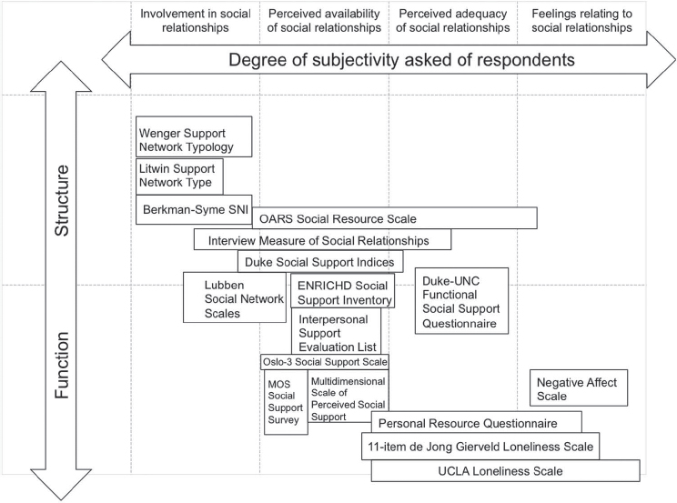

**Figure 1. Loneliness Scales Ordered by Subjectivity and Targeted Characteristic**

To be clear, loneliness is not just tied to the active establishment of connections, but also to the passive cognitive evaluation of our existing ones. For instance, DiJulio, Hamel, Muñana, and Brodie (2018) found that people with debilitating conditions, or who were low income, single, or divorced, reported feeling more lonely than less downtrodden individuals, even if the extensiveness of their social network was the same. In fact, disadvantaged individuals with condensed, smaller groups were found to be affected by lower rates of loneliness. This doesn’t mean that having many friends does not contribute to a person’s wellness. On the contrary, it is the amount of social capital, support and trust that determines personal evaluations of relationship quality, and people who might require additional help will consequently hold higher standards for their friendships, lest making their networks feel shallow (Putnam, 2000). Quite, the relationship between an individual’s number of friends and wellness is not as linear as many people think, but instead curvilinear, with Russel, Cutrona, McRae & Gomez (2012) noting that individuals who extend past their optimal social network extension[9] will actually begin to experience decreases in wellness. The problem then rises from trying to capture this feeling of contentment while addressing a person’s own unawareness of what being alone means, either by concentrating on simpler counts of friend groups and relative engagement, thus ignoring the problem, or by omitting physical loneliness altogether (Prohaska et al., 2020).

This study tries to reconcile the problem of separating measures of emotional and physical loneliness. In specific, the paper tries to demonstrate that consideration of one aspect of loneliness does not preclude another and that the effect of loneliness on wellness is based both on different ideals of social network depth, and one’s own way of engaging with said network. In fact, preexisting values, such as cultural differences (DiJulio et al., 2018), residential location (Van Beek & Patulny, 2022), and dramatic life events (i.e., COVID-19; Luchetti et al., 2020) may cause people to both experience and act our loneliness differently, and an evaluation of the behavioral, rather than emotional outputs of loneliness may allow for a more comprehensive study of social wellness.

*Research Question 2*: Can physical and mental loneliness be measured simultaneously while still effectively capturing their separate effect on wellness?

## **Social Engagement as a Mediator between Mental Wellness and Loneliness**

Community and social engagement can be used as a measure of effective social cognition and identification, bridging the differences between online and physical communication by associating feelings of connectedness with willingness to participate in the community. As a matter of fact, a good way to track how loneliness affects relevant wellness factors, such as individual health and relational outcomes, can come from the inclusion of perceived social belonging and community-based identity setting within the evaluation of personal wellbeing (van Eldik et al., 2019); in other words, determining the degree to which an individual’s commitment and assigned trust to a community, real or online, leads to their direct participation to it, and the emotional consequences that such participation brings back to the individual. To further elaborate, what usually drives civic engagement and member health is the combined perception of a functional community, and the degree to which it allows the coexistence and interdependence of its members (Bjornstrom et al., 2013), meaning that strong, participating communities are often associated with strong social capital, which in turn is also connected with strong relationship ties. This makes it easier to detect an individual’s social and emotional wellbeing, without necessarily relying on personal evaluation (Collins et al., 2014; Procentese et al., 2019).

Quite, contrary to typical measures of emotional and physical loneliness, civic engagement measures do not depend on subjective, and thus variable, opinions of social cohesion and social capital, and can be traced back to active political activities such as volunteering, charitable giving, political donation, political representative engagement, voting, citizenship, political expression etc. (Atkinson et al., 2020). In addition, causal research surrounding civic engagement makes it easier to pinpoint its specific effect on individual wellness, as potential confounding effects that could inflate the role of communities within perceptions of social trust and connectedness are more clearly outlined than research directly addressing loneliness. Of these, the most prevalent are religion (Whitehead & Stroope, 2015), cultural and national context (Crocetti et al., 2012), temporal engagement[10] (Wray-Lake et al., 2019), political ideology (Ferrucci et al., 2020), and group heterogeneity (Costa & Khan, 2003). To give an example, the latter two unite the areas of civic engagement, online communication, and well-being, since political affairs tend to discourage the forming reciprocity-based groups over interest-based groups (Figure 2; Holt-Lunstad & Steptoe, 2022), which in turn creates more heterogenous and disconnected relationship ties, and thus reduced wellness (Johnson et al., 2010).

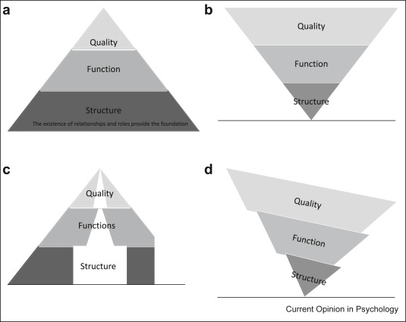

**Figure 2. Modern Network Types[11]**

Regardless, online groups have the possibility of creating strong reciprocity-based ties as long as the personal self and the online self remain congruent (Cover, 2012)[12]. Verily, merging one’s real identity with the online one allows for a simple transfer of social network benefits between online and offline relationships, meaning that increasing one’s social capital online is equal to doing so offline (Holmberg, 2014). As established, civic engagement and well-being are directly correlated with the perceived intimacy and strength of a person’s close relationship net (Lee et al., 2018), therefore the internet and social media could allow both the reinforcement of offline relationships and their diversification according to individual interests (Wellman et al., 2002; McCully et al., 2011).

**H3**: High levels of social cohesion will have a significant positive effect on wellness.

**H4**: Individuals with both high levels of social cohesion and high levels of loneliness will experience significant positive effects on wellness.

The advantage of using civic engagement as a mediator between loneliness and wellbeing is that it detects a person’s individual feeling of connectedness rather than its real physical connectedness (Bjornstrom et al., 2013). In other words, engagement can indicate if a person values the intimacy of their social network enough to identify with it and thus participate in it (Subramanian et al., 2006); a relationship which can also be detected within online communities. However, in an online context where heterogeneity is common and weak relationships prevail, the absence of meaningful offline support may hinder the positive effect of community participation, even if engagement remains high, and while online communication finds prevalent use in information sharing and peer communication, the activity itself does not directly increase a person’s involvement in the community, rather the quality of the established relationship does (Moy et al., 2005).

**H5**: Engaging in a high number of offline political activities will have a significant positive effect on wellness.

**H6**: Engaging in a high number of online political activities will have a significant negative effect on wellness.

## **The Detrimental Effect of Loneliness on Health**

The need to properly measure loneliness goes beyond simple mental health needs, as chronic isolation can lead to severe psychosomatic complications, such as strokes, suicidal thoughts, depression, anxiety, chronic health conditions, and dysfunctional health behaviors (Park et at., 2020)[13]. In fact, in their 2018 Kaiser Foundation report, DiJulio et al. found that most people in the U.S. considered declines in mental and physical health to be the worst consequences of prolonged loneliness (58% and 55% of respondents, compared to the 49% prioritizing declines in personal relationship quality), while meta-analyses by Holt-Lunstad and his research groups (2015, 2022) confirmed that social loneliness, emotional loneliness, and physical loneliness each increase the risk of mortality by 29%, 26%, and 32%. In essence, problematic internet use is a worrying determinant of the country’s health, as individuals crave to experience more without perceiving the negative effects it brings. Dysfunctional communication patterns then cause a higher reliance on problematic use, falling within an exacerbating cycle which has dire consequences on an individual’s wellness and social wellbeing.

The literature surrounding the relationship between wellness and loneliness specifically mentions cardiovascular diseases, cognition declines, increases in depression and anxiety, and a worsening of chronic and dysfunctional health behaviors as the most worrying effects on individual health:

***Cardiovascular Diseases.***Individuals with higher levels of self-reported loneliness experience increases of up to 14.4 mmHg of systolic blood pressure, leading to severe hypertension, and higher chances of atherosclerosis (Xia & Li, 2018). In addition, their incidence of coronary heart diseases and stroke was 1.29 times higher lower levels of self-reported loneliness (Paul et al., 2021). Rates remain the same across age and gender, but older adults are reported to feel these effects more from real rather than perceived social isolation (National Academy of Sciences, Engineering, and Medicine [NASEM], 2020).

***Cognition and Self-Reported Health.***The worst outcomes are found across seniors and people with underlying mental conditions, such as schizophrenia, obsessive compulsive disorders, bipolar disorder etc., with higher loneliness being associated with an increased rate of impairment and longer times of disease remission (Wang et al., 2018; NASEM, 2020). People over 65, in particular, tend to be burdened by the most troublesome consequences of prolonged loneliness, with 30% of the senior sample in Hämmig’s (2019) study of loneliness’s generational health effects reporting a general decline in self-rated health. This finding was also confirmed by Launaigh & Lawlor (2008), which attribute loneliness to higher rates of Alzheimer’s Dementia, with higher ranges of effect being detected among abandoned elderly (Luanaigh & Lawlor, 2008)

***Depression and Anxiety****.* The association between loneliness, social isolation, and mental health comes both from a biomedical explanation of hormonal and organic dysfunction, such as cortical accumulation and HPA axis inflammation, and a maldeveloped social cognition framework, which can be addressed with therapy or pharmaceuticals (Park et al., 2020). In fact, emotional, rather than social and physical loneliness, is associated with higher incidences of major depressive disorders and generalized anxiety disorders (Hyland et al., 2019). Other reports denote an association between increases in suicidal ideation and attempted suicides, and individuals afflicted by both real and perceived isolation (Stickley & Koyanagi, 2016)

***Chronic Health Conditions and Health Behaviors***. People suffering from higher levels of emotional loneliness also report greater comorbidity with pre-existing conditions and increased engagement in dysfunctional activities such as smoking, drinking, drug use, unhealthy diets, and physical inactivity; specifically, prevalence rates increase by 15% or 20% depending on higher and lower loneliness distributions (Hämmig, 2019). The isolation forced by the pandemic did not aid those who were trying to improve their coping strategies, as opportunities for change were limited during quarantine and stay-at-home orders (Brewer et al., 2022). To this point, elders experienced severe interruptions in therapeutic activities which resulted in greater losses in functional mobility and independence (NASEM, 2020).

All studies addressing the relationship between health and loneliness incur in the same problem of separating emotional from physical loneliness (Holt-Lunstad et al., 2015, Luanaigh & Lawlor, 2008), usually addressing one or the other without considering the connection between the two. Furthermore, the changes in communication patterns witnessed during the 2000s (Norris, 2002)[14], and during the pandemic, makes it even more difficult to exactly determine isolation, thus guiding research towards subjective determinants of loneliness. Social media helps track connectedness in part, with specific attention given to the increase in use within the older age bracket, and the trend of smaller site-based groups being absorbed by larger platform-based communities (Mander et al., 2020). To this point, seniors have actually benefited from the increased connectivity afforded by online communication, and positive health outcomes can be attributed to its capacity to compress otherwise isolated communities. Yet, it can be difficult to determine if that is the result of a re-establishment of previously held social connections, or an overall expansion of their original support network. What is clear then is that “feeling alone” is not quite the same as “being alone” anymore, and happiness and health factors become increasingly harder to track if their main determinant is the evaluation of the individual’s quality of relationships (Pittman, 2018).

## **The Influence of Individual Characteristics and Context on Loneliness Effects**

Thus, the area of online communication is not as straightforward as it may seem: the position of physical and emotional loneliness within the effect of increasing or decreasing wellbeing, health, and civic engagement can change depending on its analytical definition, subjective existing networks, and established level of societal belonging. Even the interactivity of social networks can cause significant confounding when analyzing the role of weaker peer relationships on wellness. In fact, Kaufman, Rodriguez, Walsh, Shafranske and Harrell (2022) found that the influence of intimate relationships on wellbeing may potentially mask the beneficial effect of online ties, as they become only significant when individuals feel more detached from partners and family. The change in the subjective importance of the relationship itself explains why this occurs, since satisfying one’s needs for connecting with people (Demir et al., 2013; Demir & Davidson, 2013)[15] occurs at all levels of intimacy, but becomes more valuable with a preexisting appreciation of the ones we interact with (Demir, 2010).

A final note is then provided by High and Colleagues (2022), whose meta-analytical work on online communication and wellbeing represents the fundamental basis of this paper. In fact, the main reason behind the contradictory reports on the positive versus negative effects of social media may come from differences in perspective between communication-based and psychology-based research; thus, they identify a bias in both study methods and measures. Meier and Reinecke (2021) further elaborate this point by reporting that current research lacks on pattern analysis of internal communication (within social network) compared to external communication (across social networks), with a greater focus being given to straightforward counts of messaging and social interaction streams. To be clear, omitting context and individual patterns of interaction can cause severe bias in the study of online and civic engagement. For example, studying political ideology extremism within online forums by counting engagement instead of intent could misattribute those that just wish to participate for the sake of discussion, or want to see what is going on, close to individuals that do support the relevant ideology.

As such, this paper embraces a behavioral approach to the social and technical effect of social media on a person’s well-being, as well as its relationship network quality (Ellison et al., 2022). It values the contextual need for online engagement when considering the current intent of the agent/user, evaluating if this falls within the area of social engagement, social capital or social support. By doing so, the paper is able to capture the lost nuances of why a person engages in online versus offline communication, while also maintaining the overall count of how they do it, and what they gain or lose from doing so.

# **Data and Methods**

## **Data Used**

***General Social Survey***

The main dataset used in this analysis was the General Social Survey, a nationally representative survey of the attitudes and behaviors of U.S. adults, pulled from the official National Opinion Research Center (NORC) website. The survey is taken by NORC every one to two years, with cumulative cross-sectional datasets available from the year 1972 to 2021[16]. The specific data employed will come from the 2016-2020 Panel (Davern et al., 2022) updated in April 2022, which sampled 6,200 housing units in 2016, with a final tally of 2,867 completed individual interviews, and 5,200 housing units in 2018, with a final tally of 2,348 respondent individuals. While the total number of recorded observations was 5,215, considering that only a fraction of each year’s respondent also participated to the 2020 survey[17], the total number of identifiable observations was 1,823 (34.95%). To track the same respondents across waves, only those who participated in the 2018 survey were considered (1,014).

***American National Elections Survey***

All respondents who completed the 2020 wave of the GSS and were U.S. citizens at the time of study were then offered to answer a second survey administered by the American National Elections Study (ANES). The ANES is one of the oldest continuous series of survey data of electoral behavior and general attitudes in the United States and it is used here to track social participation determinants as mediators between loneliness and wellness. By tracking political involvement within the United States, the variables extracted from the ANES offered a clearer view of the role of community participation within patterns of online and offline communication. In fact, the surveys are taken before and after presidential and national congressional elections (Howell, 2022), granting an additional panel observation year to 635 GSS respondents. In order to utilize this dataset and its information in the analysis, the model sample was limited to these 635 observations.

**Table 1. Descriptive Statistics of the Selected Sample (Demographic)**

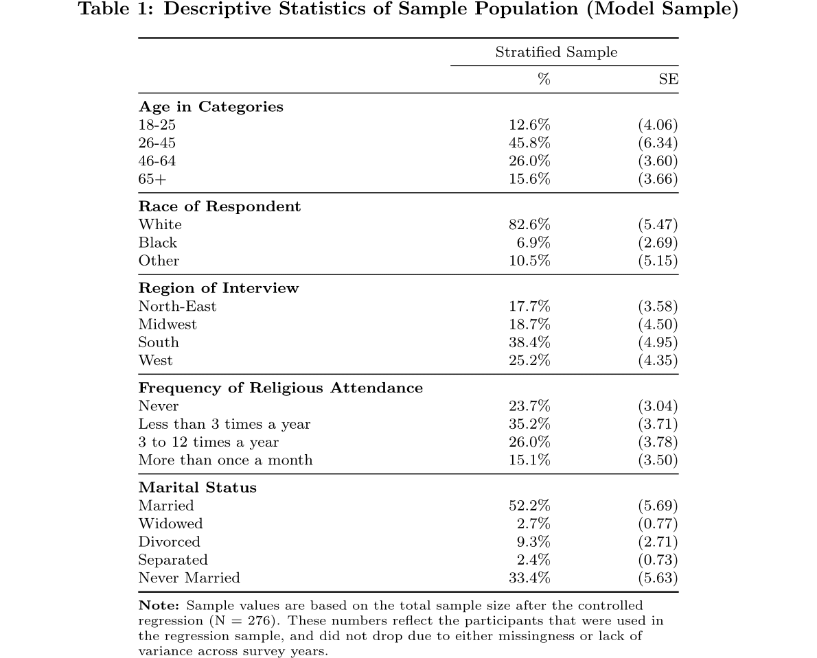

## **Addressing Missingness**

Panel data is unfortunately prone to missingness due to attrition or methodological changes across panel years. In fact, even in the 2016-2020 panel, though wording remains relatively identical across included variables, certain questions are either omitted or changed from the 2016 and 2018 waves to the 2020 wave. Although non-response negatively affects the explanatory power of certain variables, the 2016-2020 panel was selected for its relative stability in questionnaire variation and representativeness compared to other panels. In fact, a previous analysis by Smith and Son (2010) on the patterns of missingness within the 2006-2008 survey panel indicates that more complex questions tend to be the ones to attract missingness, prompting the use simpler questions to avoid attrition. Furthermore, certain questions with similar prompts across years were used to compensate for the possible lack of questionnaire continuity between 2018 and 2020.

## **Dependent Variable**

Self-Perceived happiness (*happy*) was measured through a 3-point scale answering the following: “Taken all together, how would you say things are these days—would you say that you are very happy, pretty happy, or not too happy?” The scale adopted the Very Happy, Pretty Happy, and Not Too Happy distinction, which was not modified for easier categorization. An alternative happinessvariable (*anes_satisfaction*) was obtained through the ANES addendum, which asked the respondents to answer the following: “All things considered, how satisfied are you with your life as a whole these days?” The answers were collapsed from their original 5-point format to the 3-point scale of the first happiness variable to maintain consistency.

## **Independent Variables**

The calculation of the independent variables varied across years, as not all elements of the 2018 questionnaire were included in the 2020 questionnaire. However, the wording of differentiated variables was similar across the two waves, and the ANES addendum helps complement the missing aspects of certain omitted variables. To this latter point, certain variables were combined to complete the missing information.

***Social Cohesion***

Measures for social cohesion in the GSS came separated into three variables with three ordinal set of responses, going from (1) positive to (3) negative: *trust* (“Generally speaking, would you say that most people can be trusted or that you can't be too careful when dealing with others?”), *fair* (“Do you think most people would try to take advantage of you if they got a chance, or would they try to be fair?“), and *helpful* (Would you say that most of the time people try to be helpful, or that they are mostly just looking out for themselves?”).

In this paper, the parameters were standardized into a 0 and 1 dichotomy, collapsing the neutral “Depends” answer, common to all three, into the 0 level (Carl & Billari, 2014), and a scale was created measuring from 0 (“Not Fair, Not Helpful, Not Trustworthy”) to 3 (Fair, Helpful, Trustworthy. The index was then further collapsed into a 0 to 1 dummy, which has been proven to be effective in other contexts (Mewes et al., 2021).

The scale permits an easier indication of degrees of social cohesion, while treating all components with similar weight of importance (Glanville et al., 2013; Paxton, 1999).

***Loneliness***

Frequency of loneliness was identified on a 5-point scale going from “Never” to “Very Often” by the *lonely3* parameter (“How often in the past 4 weeks have you felt that you are left out?”) in 2018, and by the *lonely1* and *lonely2* parameters (“How often in the past 4 weeks have you felt that you lack companionship?”; “How often in the past 4 weeks have you felt that you are isolated from others?”) in 2020.

While *lonely1* and *lonely2* could create the mental and physical loneliness combination the study is meant to consider (Holt-Lunstad & Steptoe, 2022), *lonely3* seemed to only represent emotional loneliness seen as perceived isolation in 2018 (Prohaska et al., 2020). As such, the variable *conwkday* (“Please indicate about how many people do you have contact with on a typical weekday irrespective of whether you know them or not. Include anyone you chat with, talk to, or text, either face-to-face, by phone, internet or any other communication device.”) was paired with the *lonely3* variable in 2018 as a way to mirror the physical-emotional dichotomy available in 2020. Particularly, *conwkday* distinguished 5 ordinal categories of weekly physical interaction counts, going from “0-4” to “50 or more”, which made it easier to combine it with *lonely3* as a 9-point scale.

Both combinations were finally collapsed into a matching 3-point scale, indicating frequency of feelings of loneliness as “Rarely”, “Sometimes” or “Often”, which would simplify tracking differences in wellness effects (Lee & Lee, 2010; Vacchiano & Bolano, 2021). Previous literature predicts that just physical loneliness should have a small, though still negative, effect on wellness if we take into account a person’s preferred method of communication (Digital or Physical; Steafnone et al., 2011), though the inclusion of mental loneliness in the dependent variable might change this relationship significantly.

***Communication Methods***

Use of communication methods was determined by the variable *intcntct* (“Think now of your contact with all of your family members and close friends. How much of it is through text messages, mobile phones, or other communication devices that use the internet?), which tracks a person’s frequency of online communication beyond work-related activities.

The responses are measured on a 6-point scale (“All of it”, “Most of it”, “Half of it” “Some of it”, “None of it” and “Never used”), which were reduced to a dummy using the first two categories as a “High Online Presence” category (1) and the other four as a “Low to Mid-Level Online Presence” category.

In the same vein as loneliness, the 2018 *intcntct* variable does not have a direct counterpart in 2020, prompting the use of the ANES to complement the missing panel year with nine separate social media use indicators. These were derived from the multiple-choice question “Which social media platforms have you visited in the past year?”, and coded as dummies; for the purpose of this study, these were grouped into a scale and then collapsed into a binary. The newly created dummy distinguished high levels of online presence (1) and low to mid-levels of online presence (0)[18], wherein, to qualify as high presence, individuals had to at least have used five different social media sites in the past year, while others were coded as mid to low levels.

***Political Participation***

Political participation frequency in 2018 was tracked through the *partpart* variable on a 5-point scale, going from “Once a Week or More” to “Never” (“In the past 12 months, how often, if at all, have you taken part in the activities of political parties, political groups or political associations?”). For its 2020 counterpart, the ANES annex was preferred as it operationalized the same prompt into nine different questions tracking political participation for distinct political activities. To be precise, these asked for an individual’s participation in political arguments, marches, religious organizations, money donations, online discussions, community problem-solving, school management, and volunteering.

While variables in both years had to be collapsed into dummies, the process to do so was different. The 2018 variable, tracking political participation in general, already divided individuals who never participated in political activities (0) with individuals who participated at least once in the past year (1), requiring no additional manipulation.

On the other hand, the 2020 engagement variable was divided into two dummies (one tracking online political participation and one offline political participation) indicating if a person had participated to at least three of the following activities per dummy:

**Table 2. Political Participation Activities for Offline or Online Contexts**

|  |  |
| --- | --- |
| **Online Political Participation** | **Offline Political Participation** |
| Online Political Meetings and Events | Physical Political Meetings and Events |
| Posting Political Issue Comments Online | Working with Others in Community Issues |
| Signing Internet Petition | Attending Meetings on Community Issues |
| Political Arguments | Political Arguments |
| Donating to Social Organizations | Donating to Social Organizations |

Following this, each dummy was paired with a copy of the general political engagement variable in 2018 (*partpart*), to verify how preference of online or offline activities might influence loneliness effects on wellness.

Once again, including political participation introduces a behavioral aid to tracking loneliness at high levels of either online communication or social cohesion, which grants higher visibility on the expected negative effect of perceived isolation on happiness (Moy et al., 2005).

## **Controls**

Just as a repeated exposure to digital communication may change a person’s preferences in methods of interaction, certain individual characteristics or habits may also influence the likelihood that a lonely person may feel more or less happy. Of these, the most cited in the literature are marriage happiness and cohabitation status, religious attendance and volunteering activities, and nature of occupation.

In the case of marriage status, individuals in relationships living with their partners are widely reported to be happier than single individuals (Prohaska et al., 2020; DeMaris, 2018). Accordingly, the variable *marcohab* tracks both if an individual is married (1) or not married (3), as well as if they are not married, but cohabitating (2), accounting then for intimacy effects with one’s partner.

Of course, wellbeing can also be associated with direct activities rather than passive characteristics, and the literature warns of the confounding effect of volunteering and religious services (Dunbar, 2021; Lewis et al., 2013; Lim & Putnam, 2010). To reduce bias, the *partvol* dummy, indicating if respondents had done any volunteering work or given money to a religious organization, was included to account for the first effect, while *attend* was used to capture religious service attendance (“How often do you attend religious services?); the latter variable was not modified from its original 8-point scale, going from “Never” to “Several Times a Week”.

Finally, the pandemic caused widespread job shifts going from physical to remote modes of activity (McClain et al., 2021), which most likely caused decreases in wellness among those who were not used to this new way of working. Since people in STEM-Designated occupations were more likely to be accustomed to remote work, and thus less likely to experience changes in happiness, the dummy *occSTEM* was included in the models, with 1 indicating people who were employed in STEM occupations.[19]

**Table 3. Descriptive Statistics of the Selected Sample (Main Model Variables)**

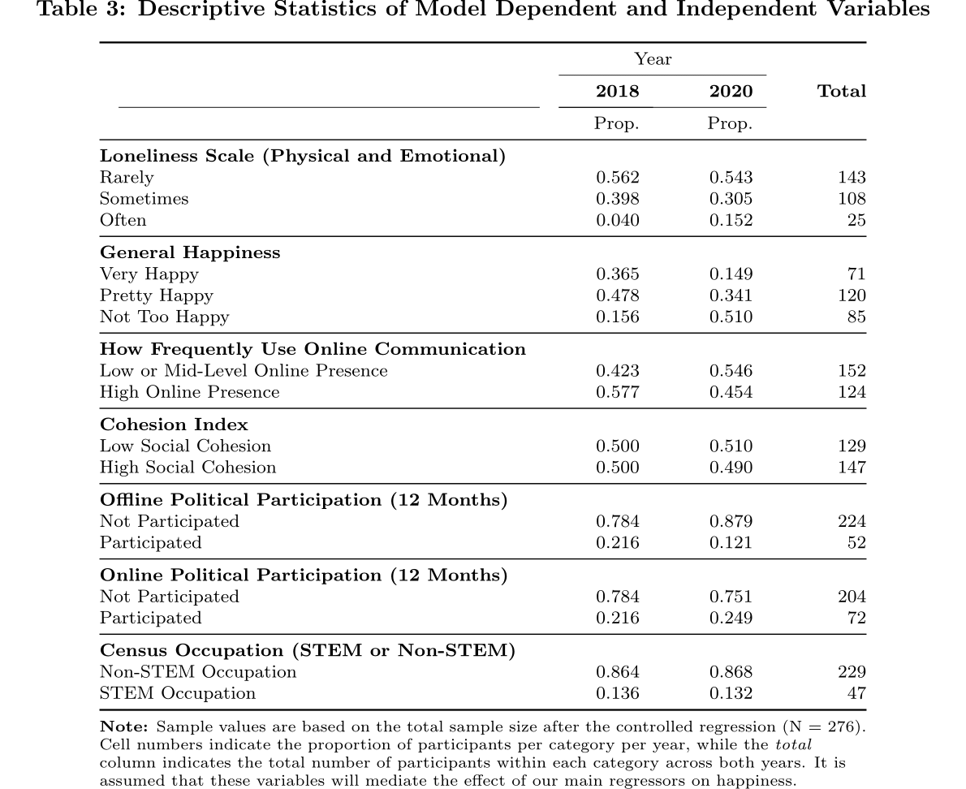

## **Model Specification and Testing**

The effect of loneliness on our variable of interest was measured at a high to low categorical scale, expecting increased effects on the extreme ends of the distribution, while the majority near the mean either does not experience significant correlations or sees relationships different from the tails. As such, the model used was a multinomial logit fixed effects, with the dependent variable being coded as to distinguish the three distinct categories (High, Medium, Low). In running the regressions, the base category for all variables was the one corresponding to “Medium”, in order to capture the specific relationship between very low loneliness and very high loneliness with high or low levels of happiness compared to mean levels of both.

The choice of Fixed Effects over Random Effects arises from the presence of the same individuals across waves, which allows us to account for time-invariant observed characteristics without the need for further controls (Park, 2011). Furthermore, our interests lie in the direct effects of our independent variables, not the idiosyncratic error terms, and the use of this model may exponentially reveal relationships hidden by unaccounted confounders, especially since we have a limited number of respondents and time periods to analyze (Yang & Land, 2008)

The models were run alternatively, with interaction terms for loneliness and the main independent variables (*intcnct* and *cohesion*) being run separately as to detect the specific changes in individual loneliness effects and the significance of the interactions. It should be noted that an ordinal logit model could have also been correct if the happiness dependent variable had been operationalized in one or two additional categories. However the limited number of categories, and the purpose of studying the simple difference in effect among high and low effect levels, warrants the apt use of these multinomial logit models:

***Online Communication Model***

***Social Cohesion Model***

While still maintaining unique categorization, and the difference between extremes and middle values, estimation of the multinomial logit model can be performed through a variety of methods that employ the reduction of the model to a binary estimation without loss of information. However, most, like *femlogit* and *feologit* (Baetschmann et al., 2015; 2020) do not allow survey setting of our datasets. In order to guarantee robust standard errors, and assuming that the command works well in small sample sizes (Riedl & Geishecker, 2014),the native *xtmlogit* was used instead.

# **Empirical Results**

Comparing the same individuals between 2018 and 2020, Social Cohesion and its interaction with high and low levels of loneliness proved to be more effective at exposing the latter’s negative interaction with wellness than online interaction levels. Quite, while the effect of loneliness is hard to determine when observing direct patterns of effect[20], introducing indicators of community identification and political engagement made it easier to identify how differing levels of loneliness can impact a person’s happiness over time. Nevertheless, running the Fixed Effects models (Table 4) reveals that each selected proxy (Online Communication or Social Cohesion) is effective at exposing the relationship between loneliness and happiness in different ways.

Before interpreting these results, since moderate happiness was used as a base category for the multinomial logit regression, all probabilities are tied to the individual’s likelihood of going from extreme levels of the happiness scale to moderate levels of mean happiness. As such, while going through anlaysis, the terminology “less likely to be happy” or “less less likely to be unhappy” will respectively refer to a higher likelihood of being moderately happy as opposed to very happy and a higher likelihood of being moderately happy as opposed to very unhappy. In the same fashion, “more likely to be happy” and “more likely to be unhappy” will respectively refer to a lower likelihood of being moderately happy as opposed to very happy and a lower likelihood of being moderately happy as opposed to very unhappy.

**Comparing Online Communication to Social Cohesion**

Within the Online Communication model, people who were happy in 2018 were less likely to be happy in the following years if they experienced loneliness very often. However, they were less likely to be unhappy if they also experienced high levels of online communication, though it is unclear if this positive effect was as strong as the negative effect of high loneliness.

On the other hand, people who were already unhappy in 2018 did not experience the same significant negative loneliness effect, but rather were less likely to be unhappy if they participated in 3 or more political activities online. The interactive term between loneliness and online communication is also significant among people who were already unhappy, though this time a combination of high loneliness and substantial levels of online communication made people more likely to be unhappy.

Within the Social Cohesion Model, accounting for how an individual felt about its community network captured loneliness effects mostly among already unhappy people. To this point, in the cohesion model, people who self-reported as unhappy in 2018 were more likely to be unhappy if they experienced loneliness very often. Interestingly, people who participated in 3 or more political activities offline were also more likely to be unhappy between panel years. Thought the causal effect of this relationship is not verifiable, when exponentiating the coefficients to derive the Relative Risk Ratios (Table 4), unhappy politically engaged people were 6.74 times as likely to continue being unhappy rather than turn moderately happy from 2018 to 2020.

In contrast, people who engaged in 3 or more online political activities were less likely to be unhappy, with a similar relationship being found among people who had simultaneously high levels of social cohesion and low to high levels of loneliness. It should be noted that the Relative Risk of being moderately happy rather than very unhappy increases as higher level of loneliness interact with high levels of social cohesion. Table 5 shows that people who reported high levels of social cohesion and indicated they rarely felt lonely were .0245 times as likely to be unhappy rather than moderately happy, while similar high cohesion people who indicated that they often felt lonely were .000215 times as likely to be unhappy than moderately happy.

As such social cohesion works best when considering extreme levels of loneliness among already unhappy people, while online communication patterns allow for a greater understanding of loneliness effects among already happy people. These interactions are especially sensible to individual time-varying characteristics, such as existing community participation, closeness to relationship neworks, and frequency of interaction with online tools. To be precise, volunteering, marriage status, and religious activity relate to a person’s likelihood of staying unhappy, while technology-tied occupations are related to a person’s likelihood of staying happy.

**Table 4. Multinomial Logistic Fixed Effects Models (GSS Happiness)**

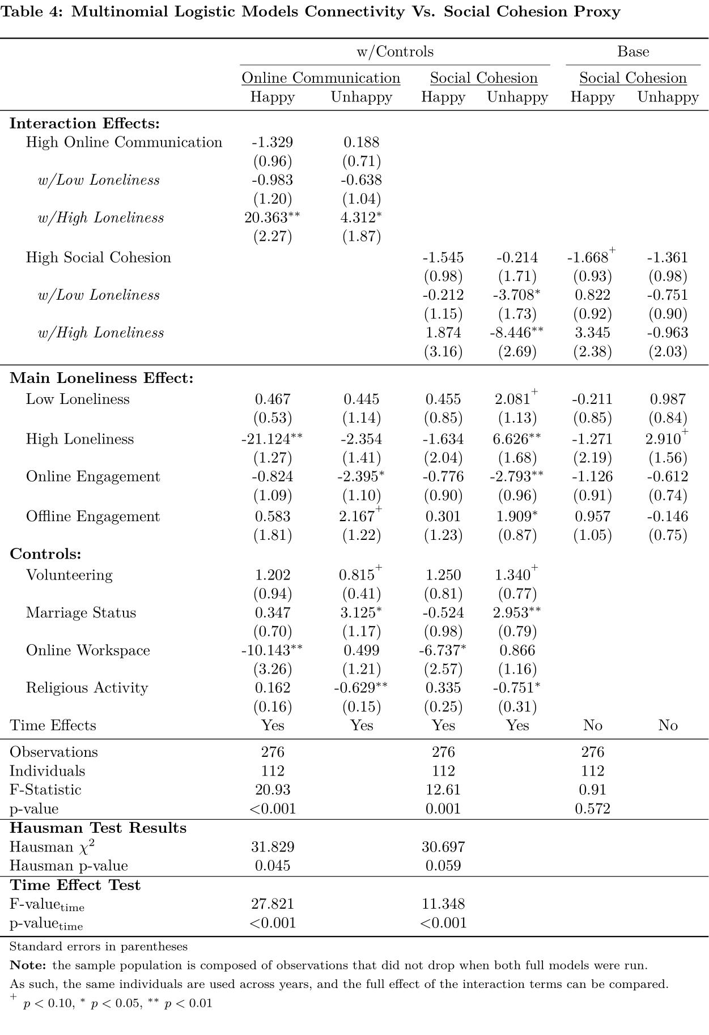

**Table 5. Relative Risk Ratios (GSS Happiness)**

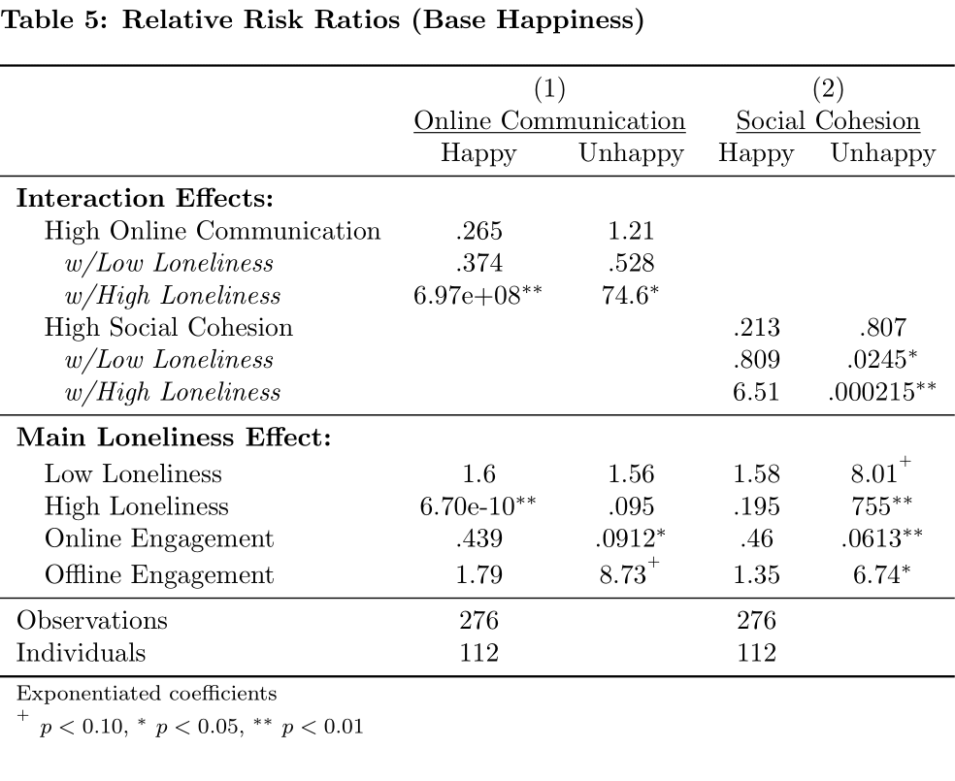

**Robustness Checks and Alternative Dependent Variable**

To confirm the assumption that a fixed effects model was necessary for the hypotheses’ analysis, a Time Effect and Hausman test were each performed on both models. These confirmed, on one side, the need for a time effect factor variable within both models at a 1% level of significance, effectively unbiasing the covariates’ effect from the error term. On the other end, the Hausman test validated the decision of using Fixed Effects, as opposed to Random Effects, in the Online Communication model at a 5% level of significance and in the Social Cohesion model at a 10% level of significance (Table 4). Alternative sampling was also used to verify if the effects remained the same when using observations common to both models, or if they changed as we used different individuals per model. Running the regressions at different sample sizes revealed the effects to be the same across methods, confirming our original results and rejecting the possibility that the effectiveness of the proxies may be due to convenience sampling.

Furthermore, while the original models used the GSS happiness variable to track happiness over panel years, the ANES survey further asked respondents to report happiness levels beyond the original 2020 questionnaire, allowing an additional layer of analysis around loneliness effects on wellness[21].

Running the models once again, online communication continues to be influential in detecting loneliness effects among happy people. As before, individuals who very often felt lonely in 2018 were more likely to feel less happy after 2020; now, however, individuals who rarely felt lonely in 2018 are also more likely to feel less happy, though the relative risk diminishes as loneliness levels decrease[22]. When using the alternative happiness variable, the role of online communication becomes much more significant, as people become less likely to be happy if experiencing high levels of online communication. However, this relationship reverses when we consider loneliness, as both high or low levels of the latter, when combined with high levels of online communication, made individuals more likely to be happy between 2018 and post-2020. Mirroring the previous individual loneliness effect, combinations of high loneliness and connectivity see higher risk ratios than combinations of low loneliness and connectivity, meaning that the lonelier a person is the more he benefits from high levels of online interaction.

In the cohesion model, the utilization of the new happiness variable shifted the significance of social cohesion as a proxy for loneliness effects on unhappiness to a proxy for loneliness on happiness. In fact, the effect of loneliness and the interaction variables has become insignificant when considering unhappy people, while happy people are now more likely to be less happy if they experience high levels of loneliness. Similarly to online communication interactions, combining high social cohesion and loneliness increases the likelihood of feeling more happy as opposed to moderately happy, though this only counts for combinations of high cohesion and high loneliness. On a further note, online engagement remains significant across both types of dependent variables, confirming that an unhappy individual who engages in 3 or more online political participation activities is less likely to be unhappy across panel years.

**Table 6. Multinomial Logistic Fixed Effects Models (ANES Dependent Variable)**

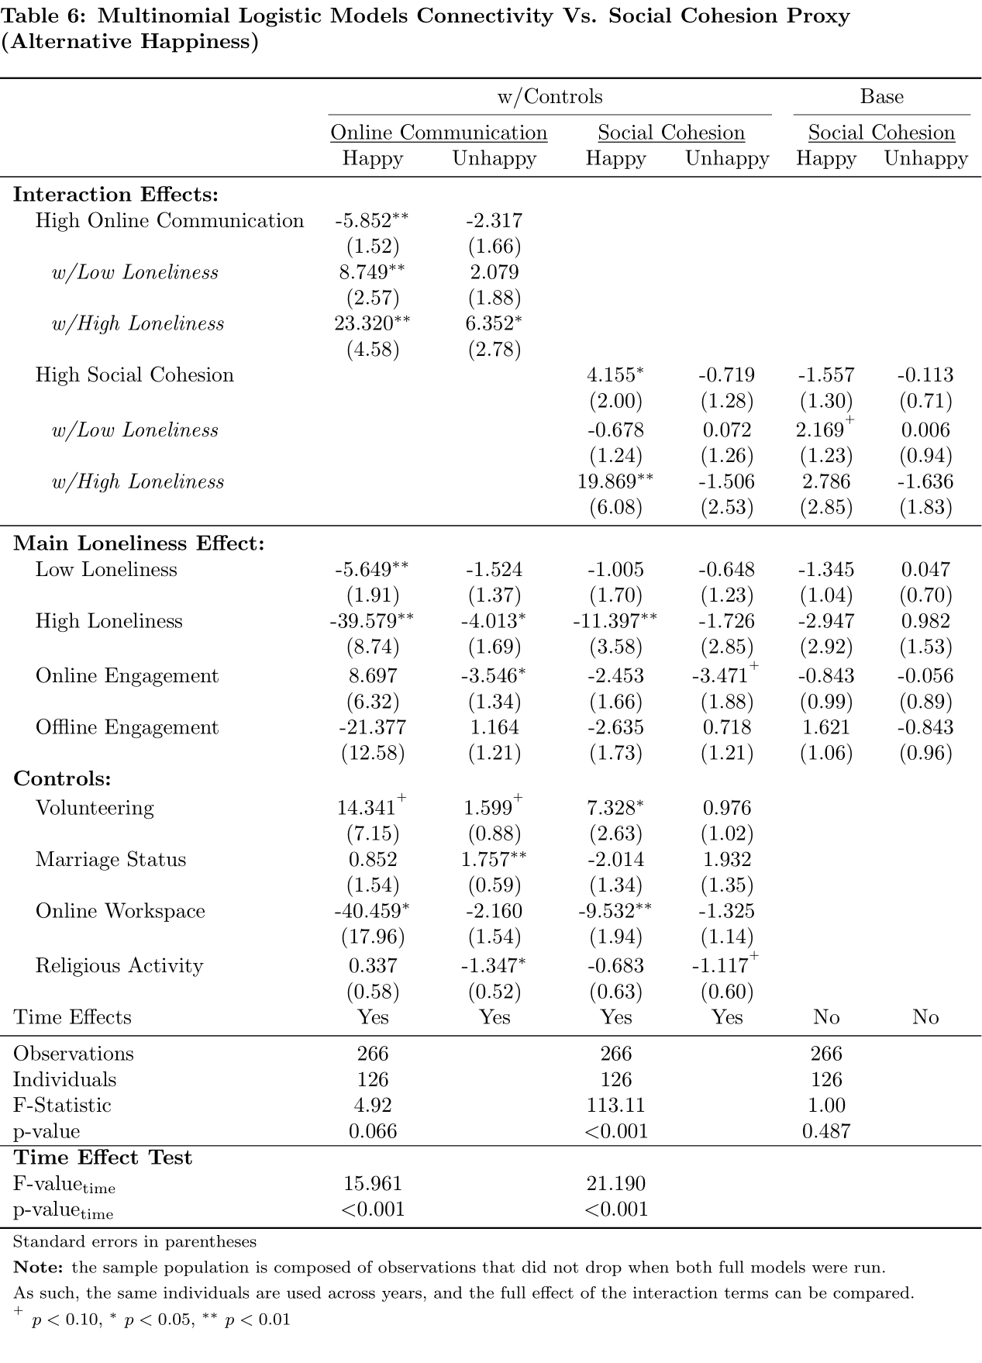

**Table 7. Relative Risk Ratios (ANES Happiness)**

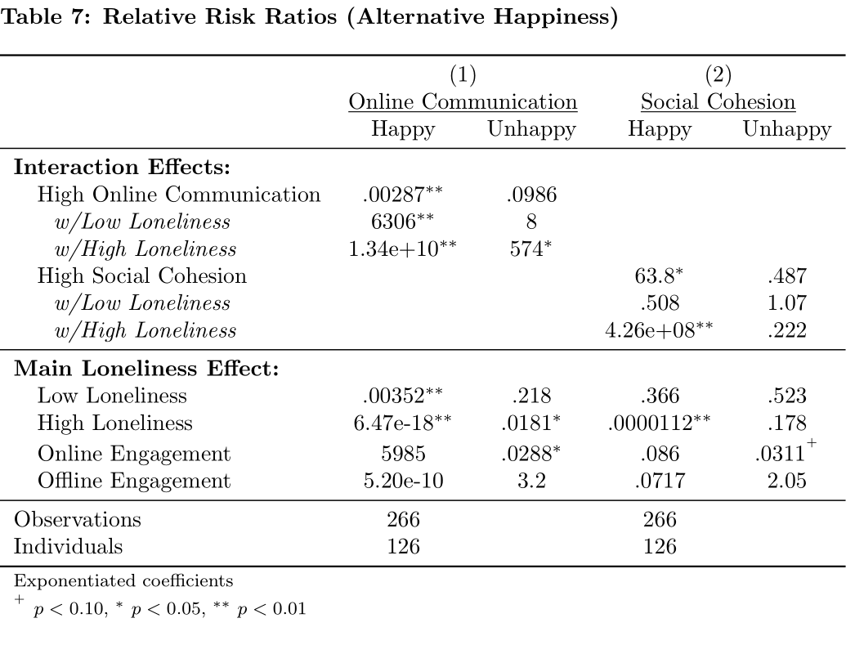

# **Discussion**

The study is successful in finding the hidden correlation between a person’s level of loneliness, either mental or physical, and indicators of wellness such as happiness. In fact, high levels of loneliness were associated with severe decreases in happiness among those in the higher end of the happiness spectrum, which could explain the reported relationship that loneliness has on mental and physical health altogether (Holt-Lunstad et al., 2022). While those that were already unhappy did not experience a similar negative effect, the shift in significance evidenced by the use of 2021 happiness reveals a trend that might expose even more Americans to the dysfunctional effects of high loneliness. All in all, the U.S. population has been facing a crisis in happiness, with Gallup pools (McCarthy, 2020) showing a small, but steady, decrease in happiness which could have been caused by the clear increases in overall loneliness (Weissbourd et al., 2021).

## **Online Connectivity as Loneliness Prevention**

The most reasonable solution would then be to try and increase connectedness among lonely individuals, yet the confirmation of the first and second hypothesis demonstrates that it might not be as easy of a solution. In fact, while higher levels of online interaction did not directly influence happiness, accounting for high levels of loneliness revealed that interacting with people online does have a positive effect on happiness among already happy people (Fawcett & Karastoyanova, 2022). However, if a person was already unhappy by the time the frequency of online communication increases, its combination with high loneliness actually aggravates unhappiness.

The effect becomes more worrying as successive study years are taken into consideration, with online communication by itself becoming more and more a driver of unhappiness, and its interaction with high loneliness only benefitting already satisfied individuals. Moreover, as already discussed above, individuals desensitized by high usages of digital tools of communication are prone to deluding themselves into thinking that they are happy (Pittman, 2018), even if still feeling very lonely. As such the effect of interactive high online communication and high loneliness might be conceptually skewed; while “perceived happiness” does increase, “real happiness” does not.

As such, although increasing interactivity is a good way to prevent loneliness, and to detect it among people who might already feel satisfied with their lives, or are just very happy, it is not a good tool to address it. On the contrary, increasing online interactions among already unhappy people just makes things worse, necessitating a different method to address loneliness.

## **Reconnecting Lonely People to their Communities**

The study proposed using social cohesion as a tool to reestablish the connection between loneliness and wellness overall, though the results showed that just limiting its role as a mediator among unhappy people might be enough. Indeed, when accounting for social cohesion, loneliness became better at explaining happiness among those at the lower end of the happiness spectrum. This is due to a re-establishment of lost determinants of social identification, meaning that people will benefit more from reconnecting with others as they feel that their relationship network is safe and trustworthy (van Eldik et al., 2019). Therefore, the more a person feels isolated, the more social connection can benefit its happiness levels.

However, social cohesion has been historically low in the past decade, and recent numbers show that the United States have been falling behind compared to countries like China, Australia, and Sweden (College & Martyn, 2020). As a result, it becomes increasingly important to find ways to sustain social cohesion so as to not incur in the most serious deleterious effects of loneliness on wellness. The main hypothesis was that engaging in political activities would increase wellness, since previous literature established that political engagement is connected with feelings of social identification and community belonging (Subramanian et al., 2006).

The results of the analysis showed that engaging in political activities does have a significant effect on happiness, just not in the way that it was expected by the hypotheses. In fact, online political engagement was more likely to lift unhappy people up the happiness scale, while offline political engagement did the opposite. The effect is preserved between the models, meaning that these relationships are not determined by neither connectivity nor social cohesion levels alone, but rather by their own influence on an unhappy person’s general satisfaction. It appears then that it is not the content of the activity itself that matters, nor the mode of execution, but rather the simple involvement, or feeling of involvement, which increases personal judgements of happiness over time (Fong et al., 2021).

It should be noted that this effect is heavily influenced by political events, as the positive relationship almost disappears when considering happiness in 2021. This represented the period after the presidential election and an almost concurrent lockdown, which could have brought severe political fatigue to the general population and thus a reluctance to engage in positive political activities (Jørgensen et al., 2022). For this reason, efforts surrounding the reduction of loneliness, and increases in both social cohesion and happiness, should not be led by far removed political institutions but by closer and trusted sources of community and neighborhood re-investment.

## **Policy Implications**

The pandemic saw significant shifts in the way we interact with each other and society at large (McClain et al., 2021), often leaving behind those who were most vulnerable or less capable of adapting to the new demands of a country under lockdown. It becomes then necessary to create opportunities for the re-establishment of valuable connections among marginalized groups such as seniors (Kotwal et al., 2021), children and adolescents (Loades et al., 2020). The results reported here indicate that such reconnection is possible through a whole-of-community approach, wherein isolated individuals are offered the opportunity to contribute to their local volunteering groups or can participate in social activities within their neighborhoods (Fong et al., 2021). It should be noted that previous literature does not support the use of active work environments, such as a job or schools, as effective locations for civic engagement (Valk, 2017).

The reason lies behind the ultimate objective of such intervention, which is to create meaningful and intimate connections more common among people with whom we share our living spaces (Bergefurt et al., 2019). Countries like France, Spain, the UK and various nations in Scandinavia have adopted programs that use this knowledge to the community’s advantage, by establishing “neighbor-friendly” support groups that provided meaningful socializing activities to both youths and seniors (Windle et al., 2011). These can go from person-to-person interventions (Befriending Networks Ireland, LinkAge), to group-based activity programs (Buurtcirkel Neighbourhood Circles Netherlands, UK Men in Sheds) and community-wide cooperation nets (KISS, MONALISA).

‌These grassroots and community-focused programs should not act as substitutes of existing national and online-focused initiatives, but rather as complementary pilots to ensure continued engagement in positively reinforcing social activities (Sandu et al., 2021). By establishing a baseline of satisfaction and happiness among unhappy populations, connectivity focused programs later become more effective in maintaining solid and healthy relationships within vulnerable populations. This goes back to the principle of online communication explained earlier, which is, as a derivative of previously established offline relationships, online communication acts as a reinforcer of intimacy and social capital (Cover, 2012).

## **Limitations**

The study presents some limitations to its design and sample choice which may diminish its generalizability and use in future projects. Primarily, the reliance on the GSS and ANES, which held a limited amount of usable observations, means that the study possesses rather low power, and might not carry its significance across higher observations counts. Furthermore, the fixed effect’s model need for significant changes across observation years meant that the number of useful individuals was reduced to a small percentage of the original observation count. While the derived sample was not significantly different from the original, this can lead to unobserved bias, which compromises the stability of the results.

Even among the original population, concerns regarding representativeness arise when considering the composition of the total observation count. In fact, the GSS-ANES data was heavily skewed towards a majority white population, with only 6.9% of the regression sample being black, and 10.5% identified as other. Furthermore, survey interviews seemed to have been concentrated in the southern regions of the US, with the North-East and Midwest composing a smaller number of observations, and the observed age groups did not represent the typically targeted populations. In fact, most of the sample was represented by middle-aged individuals (45.8%) and young adults (45.8%), without also the necessary attention being given to sex and gender.

In addition, while the random missingness encountered in the raw data meant that there was no systematic bias in the sample selection, the use of most variables was stunted by pairwise deletion and omission. Some of these problems could have been solved by employing multiple imputation by chained equation methods, however the nature of the model did not allow for it without significant sacrifices in explanatory power, and the study thus used what was already available at the time of analysis.

Considering all this, the peculiar changes in significance and effects seen between the two versions of the dependent variable could have been also explained by sample number limitations. Nevertheless, the use of simpler questionnaire prompts, the adaptation of ANES information, and the use of a fixed effects model should have dampened these risks enough to present reasonably stable results, though additional studies with more reliable data are still encouraged.

# **Conclusion and Future Directions**

With the rise of loneliness levels due to social isolation measures imposed by the pandemic, developed societies such as the United States are faced with the risk of exposing a significant part of their population to declines in mental and physical health. Furthermore, common methods of modern network regeneration, which heavily rely on online communication, instead might damage individual self-identification within real-life communities, and this study tried to uncover an alternative way to proceed towards loneliness prevention and detection. The findings indicated that political engagement, and a study of loneliness while taking into account levels of social cohesion and trust, represented the best ways to respectively address and predict wellness effects of loneliness among unhappy people. To this point, frequency of digital communication was not entirely rejected, as it served best as a prevention tool for those who already self-reported as happy but still revealed high levels of loneliness, presenting the possibility for a dual collaboration system. Consequently, whole-of-community grassroots interventions are proposed, though the scope of the study was limited by data restrictions and resource availability.

It would hence be interesting to consider if a nationally representative sample would have bore similar results to this study, and if variations in population types, such as minority skewed, or gender differentiated (male vs. female) populations, would present different results. On another note, the research could only benefit from considering different combinations in sampling, and variable measurement, as social cohesion can be expressed beyond simple indicators of fairness, trust, and helpfulness. The same could be said for the scaling of happiness, which was obtained through self-evaluation and was therefore subject to personal opinions of “satisfaction” and “wellness”. All in all, while outside the scope of this study, a greater attention should be given to the variating nature of self-evaluation, and more objective scales, such as those presented here, should be used for the advancement of preventative measures of loneliness.

# **Appendix A: Verifying Alternative Dependent Variable Correlation**

**Table A1. Covariance and Correlation Table for Happiness, Loneliness, and Health**

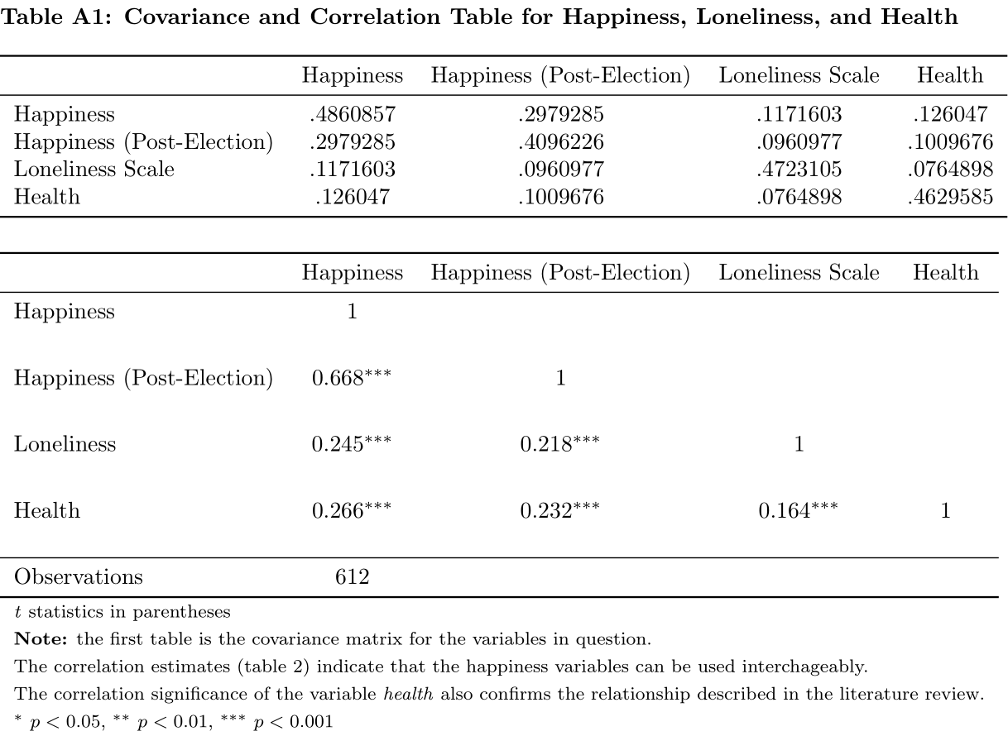

# **Appendix B: Verifying Base Level Effects**

**Table A2. Multinomial Logistic Fixed Effects Models: Base Relationships (GSS)**

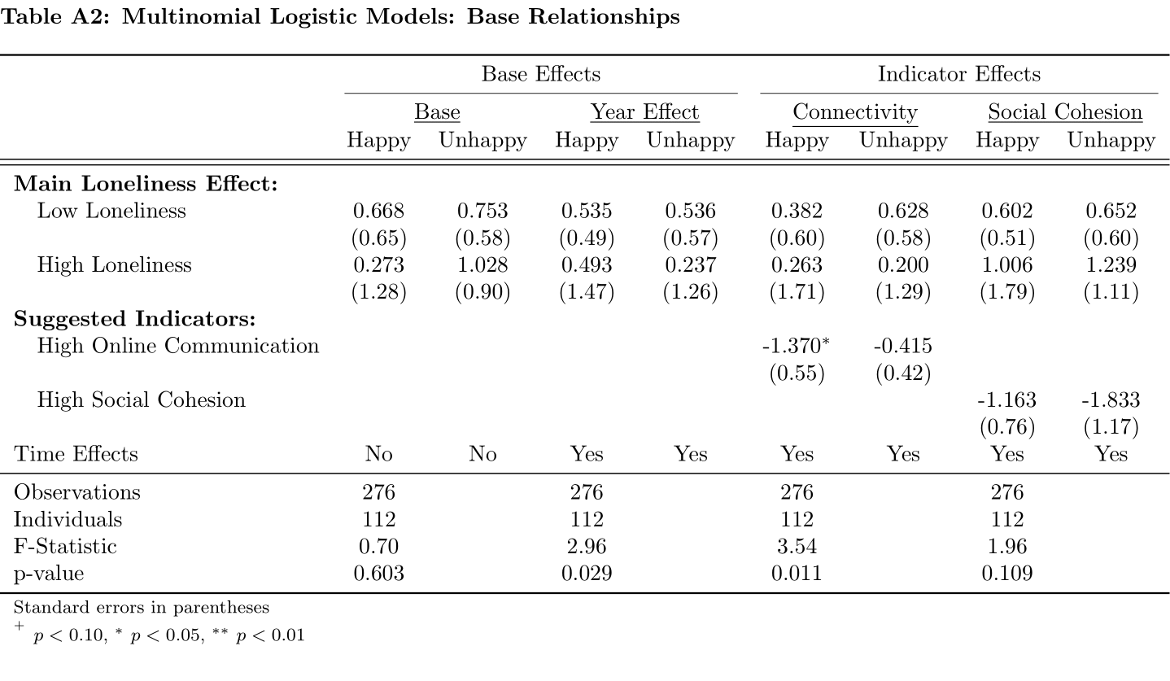

**Table A3. Multinomial Logistic Fixed Effects Models: Base Relationships (ANES)**

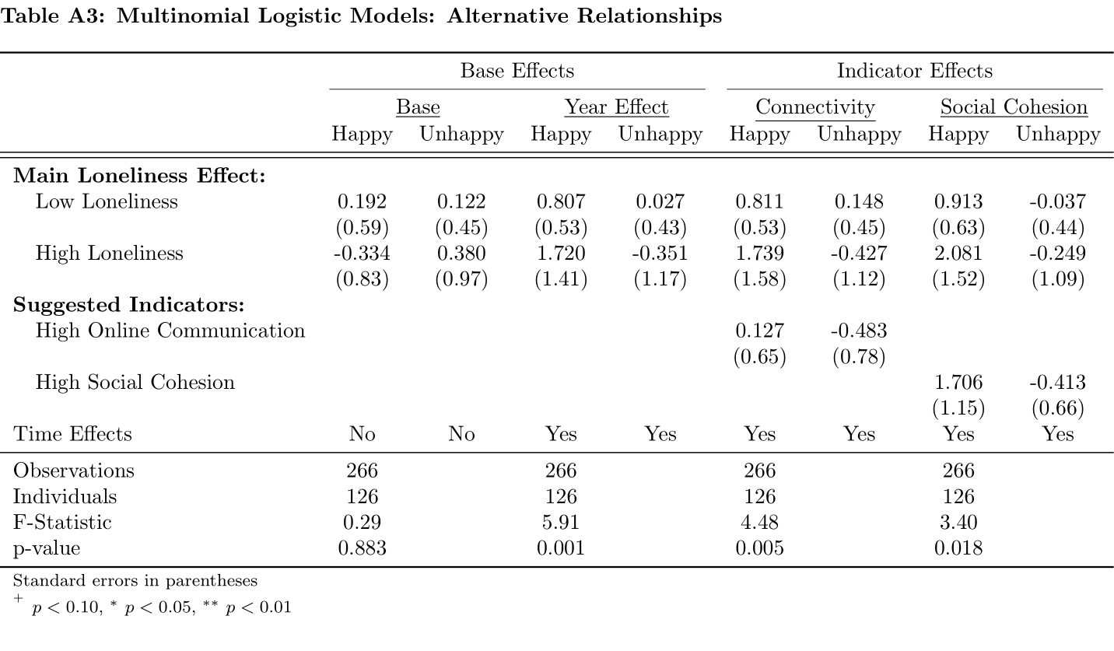

# **References**

Ahn, D., & Shin, D. H. (2013). Is the social use of media for seeking connectedness or for avoiding social isolation? Mechanisms underlying media use and subjective well-being. *Computers in Human Behavior*, *29*(6), 2453-2462.

American National Election Studies. (2022). *ANES-GSS 2020 Joint Study*[dataset and documentation]. April 8, 2022 version. [www.electionstudies.org](http://www.electionstudies.org/)

Atkinson, S., Bagnall, A. M., Corcoran, R., South, J., & Curtis, S. (2020). Being well together: individual subjective and community wellbeing. *Journal of Happiness Studies*, *21*(5), 1903-1921.

Auxier, B., & Anderson, M. (2021). Social media use in 2021. *Pew Research Center*, *1*, 1-4.

Baetschmann, G., Ballantyne, A., Staub, K. E., & Winkelmann, R. (2020). feologit: A new command for fitting fixed-effects ordered logit models. *The Stata Journal*, *20*(2), 253-275.

Baetschmann, G., Staub, K. E., & Winkelmann, R. (2015). Consistent estimation of the fixed effects ordered logit model. *Journal of the Royal Statistical Society: Series A (Statistics in Society)*, *178*(3), 685-703.

Bekalu, M. A., McCloud, R. F., Minsky, S., & Viswanath, K. (2021). Association of social participation, perception of neighborhood social cohesion, and social media use with happiness: Evidence of trade‐off (JCOP‐20‐277). *Journal of Community Psychology*, *49*(2), 432-446.

Bergefurt, L., Kemperman, A., van den Berg, P., Borgers, A., van der Waerden, P., Oosterhuis, G., & Hommel, M. (2019). Loneliness and life satisfaction explained by public-space use and mobility patterns. *International journal of environmental research and public health*, *16*(21), 4282.

Bergstrand, K., & Mayer, B. (2020). “The Community Helped Me:” Community Cohesion and Environmental Concerns in Personal Assessments of Post-Disaster Recovery. *Society & natural resources*, *33*(3), 386-405.

Biester, L., Matton, K., Rajendran, J., Provost, E. M., & Mihalcea, R. (2020). Quantifying the effects of COVID-19 on mental health support forums. *arXiv preprint arXiv:2009.04008*.

Biester, L., Matton, K., Rajendran, J., Provost, E. M., & Mihalcea, R. (2021). Understanding the impact of COVID-19 on online mental health forums. *ACM Transactions on Management Information Systems (TMIS)*, *12*(4), 1-28.

Bjornstrom, E. E., Ralston, M. L., & Kuhl, D. C. (2013). Social cohesion and self-rated health: the moderating effect of neighborhood physical disorder. *American journal of community psychology*, *52*(3), 302-312.

Brewer, G., Centifanti, L., Caicedo, J. C., Huxley, G., Peddie, C., Stratton, K., & Lyons, M. (2022). Experiences of mental distress during COVID-19: Thematic analysis of discussion forum posts for anxiety, depression, and obsessive-compulsive disorder. *Illness, Crisis & Loss*, *30*(4), 795-811.

Carl, N., & Billari, F. C. (2014). Generalized trust and intelligence in the United States. *PloS one*, *9*(3), e91786.

Chopik, W. J. (2016). The benefits of social technology use among older adults are mediated by reduced loneliness. *Cyberpsychology, Behavior, and Social Networking*, *19*(9), 551-556.‌

Colledge, M., & Martyn, C. (2020, October 28). *Social cohesion is under assault globally*. Ipsos; [www.ipsos.com](http://www.ipsos.com). Retrieved from <https://www.ipsos.com/en/social-cohesion-pandemic-age-global-perspective>

Collins, C. R., Neal, J. W., & Neal, Z. P. (2014). Transforming individual civic engagement into community collective efficacy: The role of bonding social capital. *American journal of community psychology*, *54*(3), 328-336.

Costa, D. L., & Kahn, M. E. (2003). Civic engagement and community heterogeneity: An economist's perspective. *Perspectives on politics*, *1*(1), 103-111.

Cover, R. (2012). Performing and undoing identity online: Social networking, identity theories and the incompatibility of online profiles and friendship regimes. *Convergence*, *18*(2), 177-193.

Cramer, K. M., & Barry, J. E. (1999). Conceptualizations and measures of loneliness: A comparison of subscales. *Personality and Individual differences*, *27*(3), 491-502.

Crocetti, E., Jahromi, P., & Buchanan, C. M. (2012). Commitment to community and political involvement: A cross-cultural study with Italian and American adolescents. *Human affairs*, *22*(3), 375-389.

Cudjoe, T. K., Roth, D. L., Szanton, S. L., Wolff, J. L., Boyd, C. M., & Thorpe Jr, R. J. (2020). The epidemiology of social isolation: National health and aging trends study. *The Journals of Gerontology: Series B*, *75*(1), 107-113.

Cullen, R., & Sommer, L. (2010, January). Participatory democracy and the value of online community networks: An exploration of online and offline communities engaged in civil society and political activity. In *2010 43rd Hawaii International Conference on System Sciences* (pp. 1-10). IEEE.

Davern, M., Bautista, R., Freese, J., Morgan, S. L., & Smith, T. W. (Release 1a, 2022, April). General Social Survey Panel Data (2016-2020). <https://doi.org/10.17605/OSF.IO/HACZV>

Demir, M. (2010). Close relationships and happiness among emerging adults. *Journal of Happiness Studies*, *11*(3), 293-313.

Demir, M., & Davidson, I. (2013). Toward a better understanding of the relationship between friendship and happiness: Perceived responses to capitalization attempts, feelings of mattering, and satisfaction of basic psychological needs in same-sex best friendships as predictors of happiness. *Journal of happiness studies*, *14*(2), 525-550.

Demir, M., Şimşek, Ö. F., & Procsal, A. D. (2013). I am so happy ‘cause my best friend makes me feel unique: Friendship, personal sense of uniqueness and happiness. *Journal of Happiness Studies*, *14*(4), 1201-1224.

DiJulio, B., Hamel, L., Muñana, C., & Brodie, M. (2018). Loneliness and social isolation in the United States, the United Kingdom, and Japan: An international survey. *The Economist & Kaiser Family Foundation*.

DiTommaso, E., and Spinner, B. (1993). The development and initial validation of the Social and Emotional Loneliness Scale for Adults (SELSA). *Personality and Individual Differences*, *14*, 127–134.

Dunbar, R. I. (2021). Religiosity and religious attendance as factors in wellbeing and social engagement. *Religion, Brain & Behavior*, *11*(1), 17-26.

Ellison, N. B., Pyle, C., & Vitak, J. (2022). Scholarship on well-being and social media: A sociotechnical perspective. *Current Opinion in Psychology*, 101340.

Fawcett, B., & Karastoyanova, K. (2022). Older people, loneliness, social isolation and technological mitigations: utilising experiences of the Covid-19 pandemic as we move forward. *The British Journal of Social Work*.

Ferrucci, P., Hopp, T., & Vargo, C. J. (2020). Civic engagement, social capital, and ideological extremity: Exploring online political engagement and political expression on Facebook. *New Media & Society*, *22*(6), 1095-1115.

Filiposka, S., Gajduk, A., Dimitrova, T., & Kocarev, L. (2017). Bridging online and offline social networks: Multiplex analysis. *Physica A: Statistical Mechanics and its Applications*, *471*, 825-836.

Fong, P., Cruwys, T., Robinson, S. L., Haslam, S. A., Haslam, C., Mance, P. L., & Fisher, C. L. (2021). Evidence that loneliness can be reduced by a whole-of-community intervention to increase neighbourhood identification. *Social Science & Medicine*, *277*, 113909.

Forthman, K. L., Colaizzi, J. M., Yeh, H. W., Kuplicki, R., & Paulus, M. P. (2021). Latent variables quantifying neighborhood characteristics and their associations with poor mental health. *International journal of environmental research and public health*, *18*(3), 1202.

Gil de Zúñiga, H., & Valenzuela, S. (2011). The mediating path to a stronger citizenship: Online and offline networks, weak ties, and civic engagement. *Communication Research*, *38*(3), 397-421.

Gioia, F., Fioravanti, G., Casale, S., & Boursier, V. (2021). The effects of the fear of missing out on people's social networking sites use during the COVID-19 pandemic: the mediating role of online relational closeness and individuals' online communication attitude. *Frontiers in Psychiatry*, *12*, 620442.

Glanville, J. L., Andersson, M. A., & Paxton, P. (2013). Do social connections create trust? An examination using new longitudinal data. *Social Forces*, *92*(2), 545-562.

Gui, M., & Büchi, M. (2021). From use to overuse: Digital inequality in the age of communication abundance. *Social Science Computer Review*, *39*(1), 3-19.

Hämmig, O. (2019). Health risks associated with social isolation in general and in young, middle and old age. *PLoS One, 14*(7), e0219663.

Hampton, K. N., Livio, O., & Goulet, L. S. (2021). The social life of wireless urban spaces: internet use, social networks, and the public realm. In *Public Space Reader* (pp. 384-391). Routledge.

Holmberg, L. (2014). Seeking social connectedness online and offline: Does happiness require real contact? (Doctoral dissertation).

Holt-Lunstad, J., & Steptoe, A. (2022). Social isolation: An underappreciated determinant of physical health. *Current Opinion in Psychology*, *43*, 232-237.

Holt-Lunstad, J., Smith, T. B., Baker, M., Harris, T., & Stephenson, D. (2015). Loneliness and social isolation as risk factors for mortality: a meta-analytic review. *Perspectives on psychological science*, *10*(2), 227-237.

Howell, D. (July 14, 2022). The American National Election Studies (ANES) awarded $14 million to study 2024 elections. *ANES* [Press Release]. Accessed on November 17, 2022. <https://electionstudies.org/anes-2024-award/>

Hwang, T. J., Rabheru, K., Peisah, C., Reichman, W., & Ikeda, M. (2020). Loneliness and social isolation during the COVID-19 pandemic. *International psychogeriatrics*, *32*(10), 1217-1220.

Hyland, P., Shevlin, M., Cloitre, M., Karatzias, T., Vallières, F., McGinty, G., ... & Power, J. M. (2019). Quality not quantity: loneliness subtypes, psychological trauma, and mental health in the US adult population. *Social psychiatry and psychiatric epidemiology*, *54*(9), 1089-1099.

Johnson, T. J., Zhang, W., & Bichard, S. L. (2010). United we stand? Online social network sites and civic engagement. In *A networked self* (pp. 193-215). Routledge.

Jong-Gierveld, J. (1987). Developing and testing a model of loneliness. *Journal of Personality and Social Psychology*, *53*, 119–128.

Jørgensen, F., Bor, A., Rasmussen, M. S., Lindholt, M. F., & Petersen, M. B. (2022). Pandemic fatigue fueled political discontent during the COVID-19 pandemic. *Proceedings of the National Academy of Sciences*, *119*(48), e2201266119.

Kamalpour, M., Watson, J., & Buys, L. (2020). How can online communities support resilience factors among older adults. *International Journal of Human–Computer Interaction*, *36*(14), 1342-1353.

Kaufman, V., Rodriguez, A., Walsh, L. C., Shafranske, E., & Harrell, S. P. (2022). Unique Ways in Which the Quality of Friendships Matter for Life Satisfaction. *Journal of Happiness Studies*, 1-18.

Kearns, A., & Whitley, E. (2019). Associations of internet access with social integration, wellbeing and physical activity among adults in deprived communities: evidence from a household survey. *BMC Public Health*, *19*(1), 1-15.

Kim, J. H. (2017). Smartphone-mediated communication vs. face-to-face interaction: Two routes to social support and problematic use of smartphone. *Computers in Human Behavior*, *67*, 282-291.

Kim, J. H. (2021). The neighborhood effect of cognitive function on self-rated health: A population-based observational study. *Archives of Gerontology and Geriatrics*, *93*, 104285.

Kim, Y. C., Shin, E., Cho, A., Jung, E., Shon, K., & Shim, H. (2019). SNS dependency and community engagement in urban neighborhoods: The moderating role of integrated connectedness to a community storytelling network. *Communication Research*, *46*(1), 7-32.

Kotwal, A. A., Holt‐Lunstad, J., Newmark, R. L., Cenzer, I., Smith, A. K., Covinsky, K. E., ... & Perissinotto, C. M. (2021). Social isolation and loneliness among San Francisco Bay Area older adults during the COVID‐19 shelter‐in‐place orders. *Journal of the American Geriatrics Society*, *69*(1), 20-29.

Lee, J., & Lee, H. (2010). The computer-mediated communication network: Exploring the linkage between the online community and social capital. *new media & society*, *12*(5), 711-727.

Lee, S., Chung, J. E., & Park, N. (2018). Network environments and well-being: An examination of personal network structure, social capital, and perceived social support. *Health communication*, *33*(1), 22-31

Lee, Y. C., Malcein, L. A., & Kim, S. C. (2021). Information and communications technology (ICT) usage during COVID-19: Motivating factors and implications. *International journal of environmental research and public health*, *18*(7), 3571.

Le-Phuong, L., Lams, L., & De Cock, R. (2022). Social media use and migrants’ intersectional positioning: A case study of Vietnamese female migrants. *Media and Communication*, *10*(2), 192-203.

Lewis, V. A., MacGregor, C. A., & Putnam, R. D. (2013). Religion, networks, and neighborliness: The impact of religious social networks on civic engagement. *Social science research*, *42*(2), 331-346.

Lim, C., & Putnam, R. D. (2010). Religion, social networks, and life satisfaction. *American sociological review*, *75*(6), 914-933.

Lin, S., Liu, D., Niu, G., & Longobardi, C. (2020). Active social network sites use and loneliness: the mediating role of social support and self-esteem. *Current Psychology*, 1-8.

Loades, M. E., Chatburn, E., Higson-Sweeney, N., Reynolds, S., Shafran, R., Brigden, A., ... & Crawley, E. (2020). Rapid systematic review: the impact of social isolation and loneliness on the mental health of children and adolescents in the context of COVID-19. *Journal of the American Academy of Child & Adolescent Psychiatry*, *59*(11), 1218-1239.

Low, D. M., Rumker, L., Talkar, T., Torous, J., Cecchi, G., & Ghosh, S. S. (2020). Natural language processing reveals vulnerable mental health support groups and heightened health anxiety on reddit during covid-19: Observational study. *Journal of medical Internet research*, *22*(10), e22635.

Luanaigh, C. Ó., & Lawlor, B. A. (2008). Loneliness and the health of older people. *International Journal of Geriatric Psychiatry: A journal of the psychiatry of late life and allied sciences*, *23*(12), 1213-1221.

Luchetti, M., Lee, J. H., Aschwanden, D., Sesker, A., Strickhouser, J. E., Terracciano, A., & Sutin, A. R. (2020). The trajectory of loneliness in response to COVID-19. *American Psychologist*, *75*(7), 897.

Mander J., Buckle C., & Moran S. (2020). Social: GlobalWebIndex’s flagship report on the latest trends in social media. *GlobalWebIndex*. Retrieved from <https://amai.org/covid19/descargas/SocialGlobalWebIndex.pdf>

Marlowe, J. M., Bartley, A., & Collins, F. (2017). Digital belongings: The intersections of social cohesion, connectivity and digital media. *Ethnicities, 17*(1), 85-102.

McCarthy, J. (2020, January 10). Gallup.com; Gallup. <https://news.gallup.com/poll/276503/happiness-not-quite-widespread-usual.aspx>

McClain, C., Vogels, E. A., Perrin, A., Sechopoulos, S., & Rainie, L. (2021). The Internet and the pandemic. *Pew Research Center*. Retrieved from <https://www.pewresearch.org/internet/2021/09/01/the-internet-and-the-pandemic/>

McCully, W., Lampe, C., Sarkar, C., Velasquez, A., & Sreevinasan, A. (2011, October). Online and offline interactions in online communities. In *Proceedings of the 7th international symposium on wikis and open collaboration* (pp. 39-48).

Meier, A., & Reinecke, L. (2021). Computer-mediated communication, social media, and mental health: A conceptual and empirical meta-review. *Communication Research*, *48*(8), 1182-1209.

Mewes, J., Fairbrother, M., Giordano, G. N., Wu, C., & Wilkes, R. (2021). Experiences matter: A longitudinal study of individual-level sources of declining social trust in the United States. *Social Science Research*, *95*, 102537.

Mohnen, S. M., Groenewegen, P. P., Völker, B., & Flap, H. (2011). Neighborhood social capital and individual health. *Social science & medicine*, *72*(5), 660-667.

Moy, P., Manosevitch, E., Stamm, K., & Dunsmore, K. (2005). Linking dimensions of Internet use and civic engagement. *Journalism & Mass Communication Quarterly*, *82*(3), 571-586.

National Academies of Sciences, Engineering, and Medicine. (2020). *Social isolation and loneliness in older adults: Opportunities for the health care system*. National Academies Press.

Norris, P. (2002). The bridging and bonding role of online communities. *Harvard International Journal of Press/Politics*, *7*(3), 3-13.

Park, C., Majeed, A., Gill, H., Tamura, J., Ho, R. C., Mansur, R. B., ... & McIntyre, R. S. (2020). The effect of loneliness on distinct health outcomes: a comprehensive review and meta-analysis. *Psychiatry Research*, *294*, 113514.

Park, H. M. (2011). Practical guides to panel data modeling: a step-by-step analysis using stata. *Public Management and Policy Analysis Program, Graduate School of International Relations, International University of Japan*, *12*, 1-52.

Paul, E., Bu, F., & Fancourt, D. (2021). Loneliness and risk for cardiovascular disease: mechanisms and future directions. *Current cardiology reports*, *23*(6), 1-7.

Paxton, P. (1999). Is social capital declining in the United States? A multiple indicator assessment. *American Journal of sociology*, *105*(1), 88-127.

Pew Research Center (2021). Internet/Broadband Fact Sheet. Internet. *Science & Tech.* Accessed on October 18th, 2022 <https://www.pewresearch.org/internet/fact-sheet/internet-broadband/>

Pittman, M. (2018). Happiness, loneliness, and social media: perceived intimacy mediates the emotional benefits of platform use. *The Journal of Social Media in Society*, *7*(2), 164-176.

Procentese, F., De Carlo, F., & Gatti, F. (2019). Civic engagement within the local community and sense of responsible togetherness. *TPM: Testing, Psychometrics, Methodology in Applied Psychology*, *26*(4).

Prohaska, T., Burholt, V., Burns, A., Golden, J., Hawkley, L., Lawlor, B., ... & Fried, L. (2020). Consensus statement: loneliness in older adults, the 21st century social determinant of health?. *BMJ open*, *10*(8), e034967.

Putnam, R. D. (2000). *Bowling alone: The collapse and revival of American community*. Simon and schuster.

Rauschenberg, C., Schick, A., Goetzl, C., Roehr, S., Riedel-Heller, S. G., Koppe, G., ... & Reininghaus, U. (2021). Social isolation, mental health, and use of digital interventions in youth during the COVID-19 pandemic: A nationally representative survey. *European Psychiatry*, *64*(1).

Ren, Y., Kraut, R., & Kiesler, S. (2007). Applying common identity and bond theory to design of online communities. *Organization studies*, *28*(3), 377-408.

Riedl, M., & Geishecker, I. (2014). Keep it simple: estimation strategies for ordered response models with fixed effects. *Journal of Applied Statistics*, *41*(11), 2358-2374.

Russell, D. W. (1996). UCLA Loneliness Scale (Version 3): Reliability, validity, and factor structure. *Journal of Personality Assessment, 66*(1), 20–40. [https://doi.org/10.1207/s15327752jpa6601_2](https://psycnet.apa.org/doi/10.1207/s15327752jpa6601_2)

Russell, D. W., Cutrona, C. E., McRae, C., & Gomez, M. (2012). Is loneliness the same as being alone?. *The Journal of psychology*, *146*(1-2), 7-22.

Sandu, V., Zólyomi, E., & Leichsenring, K. (2021). Addressing loneliness and social isolation among older people in Europe. *Policy Brief*. Retrieved from <https://www.age-platform.eu/sites/default/files/AddressingLoneliness%26SocialIsolation-EuropeanCentre-Jul2021.pdf>

Scott, R. A., Stuart, J., & Barber, B. L. (2021). Contemporary friendships and social vulnerability among youth: Understanding the role of online and offline contexts of interaction in friendship quality. *Journal of Social and Personal Relationships*, *38*(12), 3451-3471.

Sessions, L. F. (2010). How offline gatherings affect online communities: when virtual community members ‘meetup’. *Information, Communication & Society*, *13*(3), 375-395.

Shakya, H. B., & Christakis, N. A. (2017). Association of Facebook use with compromised well-being: A longitudinal study. *American journal of epidemiology*, *185*(3), 203-211.

Smith, T. W., & Son, J. (2010). *An analysis of panel attrition and panel change on the 2006-2008 General Social Survey Panel*. NORC/University of Chicago.

Steafnone, M. A., Huang, Y. C., & Lackaff, D. (2011, January). Negotiating social belonging: Online, offline, and in-between. In *2011 44th Hawaii International Conference on System Sciences* (pp. 1-10). IEEE.

Stickley, A., & Koyanagi, A. (2016). Loneliness, common mental disorders and suicidal behavior: Findings from a general population survey. *Journal of affective disorders*, *197*, 81-87.

Subramanian, S. V., Kubzansky, L., Berkman, L., Fay, M., & Kawachi, I. (2006). Neighborhood effects on the self-rated health of elders: uncovering the relative importance of structural and service-related neighborhood environments. *The Journals of Gerontology Series B: Psychological Sciences and Social Sciences*, *61*(3), S153-S160.

Thibaut, J. W. & Kelly, H. H. (1959). The social psychology of groups. New York: Wiley.

Towner, E., Tomova, L., Ladensack, D., Chu, K., & Callaghan, B. (2022). Virtual social interaction and loneliness among emerging adults amid the COVID-19 pandemic. *Current Research in Ecological and Social Psychology*, *3*, 100058.

Turner, J. W., Grube, J. A., & Meyers, J. (2001). Developing an optimal match within online communities: An exploration of CMC support communities and traditional support. *Journal of Communication*, *51*(2), 231-251.

Vacchiano, M., & Bolano, D. (2021). Online and offline leisure, relatedness and psychological distress: A study of young people in Switzerland. *Leisure Studies*, *40*(3), 338-351.

Valtorta, N. K., Kanaan, M., Gilbody, S., & Hanratty, B. (2016). Loneliness, social isolation and social relationships: what are we measuring? A novel framework for classifying and comparing tools. *BMJ open*, *6*(4), e010799.

Van Beek, M., & Patulny, R. (2022). 'The threat is in all of us': Perceptions of loneliness and divided communities in urban and rural areas during COVID‐19. *Journal of Community Psychology*, *50*(3), 1531-1548.

van Eldik, A., Kneer, J., & Jansz, J. (2019). Urban & online: Social media use among adolescents and sense of belonging to a super-diverse city. *Media and Communication*, *7*(2), 242-253.

Villalonga-Olives, E., Adams, I., & Kawachi, I. (2016). The development of a bridging social capital questionnaire for use in population health research. *SSM-population Health*, *2*, 613-622.

Wang, J., Mann, F., Lloyd-Evans, B., Ma, R., & Johnson, S. (2018). Associations between loneliness and perceived social support and outcomes of mental health problems: a systematic review. *BMC psychiatry*, *18*(1), 1-16.

Weissbourd, R., Batanova, M., Lovison, V., & Torres, E. (2021). How the Pandemic Has Deepened an Epidemic of Loneliness and What We Can Do About It (pp. 1–13). *Harvard University*. Retrieved from <https://static1.squarespace.com/static/5b7c56e255b02c683659fe43/t/6021776bdd04957c4557c212/1612805995893/Loneliness+in+America+2021_02_08_FINAL.pdf>

Wellman, B., Boase, J., & Chen, W. (2002). The networked nature of community: Online and offline. *It & Society*, *1*(1), 151-165.

Whitehead, A. L., & Stroope, S. (2015). Small groups, contexts, and civic engagement: A multilevel analysis of United States Congregational Life Survey data. *Social Science Research*, *52*, 659-670.

Windle, K., Francis, J., & Coomber, C. (2011). *Preventing loneliness and social isolation: interventions and outcomes* (pp. 1-16). London: Social Care Institute for Excellence.

Wirtz, D., Tucker, A., Briggs, C., & Schoemann, A. M. (2021). How and why social media affect subjective well-being: Multi-site use and social comparison as predictors of change across time. *Journal of Happiness Studies*, *22*(4), 1673-1691.

Wong, A., Ho, S., Olusanya, O., Antonini, M. V., & Lyness, D. (2021). The use of social media and online communications in times of pandemic COVID-19. *Journal of the Intensive Care Society*, *22*(3), 255-260.

Wray-Lake, L., DeHaan, C. R., Shubert, J., & Ryan, R. M. (2019). Examining links from civic engagement to daily well-being from a self-determination theory perspective. *The Journal of Positive Psychology*, *14*(2), 166-177.

Xia, N., & Li, H. (2018). Loneliness, social isolation, and cardiovascular health. *Antioxidants & redox signaling*, *28*(9), 837-851.

Yang, Y., & Land, K. C. (2008). Age–period–cohort analysis of repeated cross-section surveys: fixed or random effects?. *Sociological methods & research*, *36*(3), 297-326.‌

Yu, R. P., Mccammon, R. J., Ellison, N. B., & Langa, K. M. (2016). The relationships that matter: Social network site use and social wellbeing among older adults in the United States of America. *Ageing & Society*, *36*(9), 1826-1852.

Zhang, X. A., & Sung, Y. H. (2021). Communities Going Virtual: Examining the Roles of Online and Offline Social Capital in Pandemic Perceived Community Resilience-Building. *Mass Communication and Society*, 1-27.

1. Results are cross referenced from the National Health and Aging Trends Study (NHATS) and an independent study by the Kaiser Foundation.
2. This trend actually preceded forced social isolation, since online community participation had been growing since 2017 (From 72% to 76% in 2019, Reddit & GlobalWebIndex, 2019).
3. While the view of digital equality here is optimistic, the literature also contends that focusing on praising growth rather than reinforcing it will lead to dangerous complacency, as new risks from the developing digital age remain unaddressed (Gui & Büchi, 2021).
4. Cyberbullying, upward comparisons, fear of missing out, overuse, problematic internet use (Gioia et al., 2021).
5. Infection Anxiety, Loneliness, Mask Fatigue.
6. Spatial and social inequalities, belonging to multiple communities at once, and temporal changes in well-being, as well as community structure types.
7. Ren, Kraut and Kiesler (2007) specifically reference Bond theory and the presence of common identity groups, which simplify their identity over the group’s existence, and bond groups, which function under intercommunicative relations across members. Topic-based groups are a simplification of the former, as norm guided entities with little empathy for existing members but attraction towards newcomer growth.
8. “Bonding social capital refers to connections between members of a network who are similar to each other with respect to social class, race/ethnicity, or other attributes. By contrast, bridging social capital is defined as the connections between individuals who are dissimilar (or heterogeneous) with respect to socioeconomic and other characteristics” (Villalonga-Olives et al., 2016)
9. Cognitive Comparison Level (Thibaut & Kelley, 1959).
10. Time spent is the only factor that may vary between offline and online engagement. For details see Moy, Manosevitch, Stamm & Dunsmore (2005).
11. **a)** bonding and bridging equilibrium, with little discomfort for the individual; **b)** prevalence of bonded relationships, but with sufficient support; **c)** large social network of shallow quality, typical of online interactions; **d)** prevalence of low quality bonded relationships, which destabilize the individual.
12. Cover (2012) specifically discusses the work that goes into creating and maintaining cognitive consistency across one’s friends and identity online, which directly copies our real-life work to avoid cognitive dissonance.
13. See Luchetti et al. (2020) and DiJulio, Hamel, Muñana, & Brodie (2018) for specific interrelationship characteristics.
14. See Auxier and Anderson (2021) for specific site use.
15. In both papers the sense of uniqueness is referenced as individuality within a shared community, which can be interpreted as usefulness without entailing intermember dependency.
16. Information obtained from the GSS website: <https://gss.norc.org/About-The-GSS>
17. Panstat tracks whether a respondent was selected and reinterviewed (1 = Selected, Eligible, and Re-Interviewed, 2 = Not Selected, 3 = Selected, but not re-interviewed, 4 = Selected, but not eligible and not re-interviewed because R was deceased, 5 = Selected, but not eligible and not re-interviewed because R was permanently incapacitated, outside the U.S., or otherwise out of scope).
18. The mentioned websites were Facebook, Twitter, Instagram, Snapchat, TikTok, Youtube, and Reddit. The other two categories were used as “other” and “none of the above” options.
19. STEM Classification was taken directly from the U.S. Bureau of Labor Statistics, and the *occ10* variable was used a base to distinguish the 23 original SOC 10 categories.
20. See Appendix A for pairwise direct correlation significance.
21. The question was answered in 2021, after the presidential election and the second wave of pandemic-related restrictions.
22. Individuals were .00352 times as likely to be very happy, as opposed to moderately happy, between 2018 and 2020, if they experienced low levels of loneliness.